Frontend Project

INT (219)

ON

**OutfitMania**

Submitted by:

**Manasvi Kumar Thakur**

**12202400**

Submitted to:

**Divya Thakur**

In partial fulfilment for the requirements of the award of the degree of

B.Tech. (Computer Science & Engineering)

School of Engineering



Lovely Professional University

Phagwara, Punjab

**TABLE OF CONTENTS**

* PROBLEM STATEMENT
* DESCRIPTION OF PROJECT
* INNOVATION AND PROCESS
* PROJECT CODE
* SCREENSHOTS

**PROBLEM STATEMENT**

OutfitMania is a web-based platform designed to address the contemporary challenge of enhancing the clothing shopping experience for users. With an emphasis on convenience and a comprehensive array of fashion choices, the platform endeavors to provide an innovative and user-centric solution in the realm of online retail, specifically catering to the fashion industry.

The modern landscape of online clothing retail presents a challenge in delivering a comprehensive and engaging shopping experience to consumers. OutfitMania seeks to address these challenges by creating a user-centric platform that revolutionizes the online clothing shopping experience. It's like having your favorite shopping mall right at your fingertips, offering an endless selection of stylish outfits, from cozy casual wear to elegant formal attire. The platform brings the joy of shopping directly to you, providing an effortless and enjoyable experience where you can browse, select, and purchase the perfect clothing items that match your unique style and preferences.

In simpler terms, OutfitMania is your one-stop digital shop, where you can explore, mix and match, and find the ideal outfit that makes you look and feel fantastic. It's like having a fashion-savvy friend who always knows the latest trends and helps you pick out the best clothing options, but conveniently available at any time, from anywhere.

This project aims to redefine the way people engage with fashion, making the process of discovering and buying clothing not just a transaction, but a delightful experience that celebrates individual style and comfort.

**DESCRIPTION OF PROJECT**

OutfitMania is an innovative online platform dedicated to revolutionizing the way users interact with and shop for clothing. It offers a comprehensive, user-friendly, and visually engaging interface to explore and purchase a wide array of fashion items. The project is primarily developed using HTML, CSS, JavaScript, and Bootstrap.

The technologies used in the development of the OutfitMania clothing website project include:

1. HTML (Hyper Text Markup Language):

* Structural Foundation: HTML is the backbone of the project, providing the structural framework for the website. It is used to define the layout, elements, and content structure, such as headers, paragraphs, lists, images, and links.
* Semantic Markup: Emphasis is placed on semantic HTML to ensure a clear and meaningful organization of content, aiding in accessibility and search engine optimization.

1. CSS (Cascading Style Sheets):

* Visual Design and Layout: CSS is utilized to style the HTML elements, defining the visual layout, appearance, and responsiveness of the website.
* Responsive Design: Media queries and other CSS techniques are applied to ensure the website is responsive across various devices, adjusting the layout and design for different screen sizes.

1. JavaScript:

* Interactivity: JavaScript is employed to add interactive elements and dynamic features to the website. This includes functionalities such as sliders, dropdowns, form validation, and other user interface interactions.
* Enhanced User Experience: Through JavaScript, the website is made more engaging, responsive, and interactive, providing a smoother and more dynamic user experience.

1. Bootstrap:

* Responsive Design Framework: Bootstrap is integrated to facilitate a responsive design by providing a grid system and pre-built components. It ensures that the website layout adapts fluidly to various screen sizes and devices.
* Component Integration: Bootstrap's components and utilities are used to maintain consistency and streamline the design process. Elements such as navigation bars, cards, modals, and forms are integrated to ensure a unified and professional appearance throughout the website.

These technologies collectively contribute to the creation of OutfitMania, offering a visually appealing, user-friendly, and responsive online platform for users to explore, browse, and shop for a wide array of clothing items. The combination of HTML, CSS, JavaScript, and Bootstrap ensures a cohesive and engaging user experience on the website.

**INNOVATION AND PROCESS**

Structure and implementation of the project :

1. Project Structure:

* HTML Pages: Created a well-organized structure for essential pages including Home, Men, Women, Accessories, About Us, and Signup modal with Buy Now modal functionality.
* CSS Styling: Implemented external CSS for each page to ensure a consistent and visually appealing design.
* Cohesive Navigation: Ensured a cohesive layout across pages for a seamless user navigation experience.

2. JavaScript Functionality:

* Event Listeners: Utilized JavaScript to add event listeners for buttons, enhancing the interactivity of the website.
* Discount Message: Implemented functionality to dynamically display discount messages, providing users with real-time information.

3. Bootstrap Integration:

* Page Components: Employed Bootstrap components, specifically cards, for the Men, Women, and Accessories pages to showcase items with associated prices.
* Modal Usage: Integrated Bootstrap modals for the Signup and Buy Now functionalities, enhancing user engagement and providing a seamless experience.

4. Testing Process:

* Conducted thorough testing across multiple browsers (Chrome, Firefox, Safari, Edge) to ensure cross-browser compatibility.
* Performed functional testing on all features, including modals, buttons, and discount messaging.

Conclusion:

The implementation of the OutfitMania clothing website involved a meticulous and formalized approach. By integrating HTML, CSS, JavaScript, and Bootstrap in a cohesive manner, the project achieved a dynamic and visually appealing online platform. The emphasis on security, optimization, and user experience, along with documentation and a forward-looking roadmap, reflects a comprehensive and well-executed development process.

**SOURCE CODE**

1. **Html Files:**

**1.1 home.html**

<!DOCTYPE html>

<html lang="en">

<head>

    <meta charset="UTF-8">

    <meta name="viewport" content="width=device-width, initial-scale=1.0">

    <title>OutfitMania</title>

    <link rel="shortcut icon" href="/images/home/favicon.ico" type="image/x-icon">

    <link rel="stylesheet" href="/CSS/home.css" async>

*<!-- <script src="/JS/home.js" async></script> -->*

    <link href="https://cdn.jsdelivr.net/npm/bootstrap@5.3.2/dist/css/bootstrap.min.css" rel="stylesheet"

        integrity="sha384-T3c6CoIi6uLrA9TneNEoa7RxnatzjcDSCmG1MXxSR1GAsXEV/Dwwykc2MPK8M2HN" crossorigin="anonymous">

    <script src="https://cdn.jsdelivr.net/npm/@popperjs/core@2.11.8/dist/umd/popper.min.js"

        integrity="sha384-I7E8VVD/ismYTF4hNIPjVp/Zjvgyol6VFvRkX/vR+Vc4jQkC+hVqc2pM8ODewa9r"

        crossorigin="anonymous"></script>

    <script src="https://cdn.jsdelivr.net/npm/bootstrap@5.3.2/dist/js/bootstrap.min.js"

        integrity="sha384-BBtl+eGJRgqQAUMxJ7pMwbEyER4l1g+O15P+16Ep7Q9Q+zqX6gSbd85u4mG4QzX+"

        crossorigin="anonymous"></script>

    <link href='https://fonts.googleapis.com/css?family=Young Serif' rel='stylesheet'>

    <link href='https://fonts.googleapis.com/css?family=Amaranth' rel='stylesheet'>

</head>

<body>

    <div id="nav">

        <div id="nav1">

            <p id="nav1P"></p>

        </div>

        <div id="nav2">

            <ul id="nav2UL">

                <li class="nav2LI">

                    <img id="logo" src="/images/home/logo1.png" alt="error">

                </li>

                <li class="nav2LI">

                    <a href="/home.html" class="navTab" id="currentPage">HOME</a>

                    <a href="/men.html" class="navTab">MEN</a>

                    <a href="/women.html" class="navTab">WOMEN</a>

                    <a href="/accessories.html" class="navTab">ACCESSORIES</a>

                    <a href="/about.html" class="navTab">ABOUT US</a>

                </li>

                <li id="signup" class="nav2LI">

*<!-- Button trigger modal -->*

                    <button id="sign" class="navTab"  data-bs-toggle="modal" data-bs-target="#exampleModal">Sign Up/ Log In</button>

*<!-- <button id="login" class="navTab">Log In</button> -->*

                </li>

            </ul>

        </div>

    </div>

*<!-- Modal -->*

    <div class="modal fade" id="exampleModal" tabindex="-1" aria-labelledby="exampleModalLabel" aria-hidden="true">

        <div class="modal-dialog modal-dialog-centered">

            <div class="modal-content">

                <div class="modal-header">

                    <h1 class="modal-title fs-5" id="staticBackdropLabel">Sign up</h1>

                    <button type="button" class="btn-close" id="clse" data-bs-dismiss="modal" aria-label="Close"></button>

                  </div>

                <form onsubmit="submitForm(event)">

                    <div class="form-group">

                      <label for="exampleInputEmail1">Email address</label>

                      <input type="email" class="form-control" id="exampleInputEmail1" aria-describedby="emailHelp" placeholder="Enter email" >

                      <small id="emailHelp" class="form-text text-muted">We'll never share your email with anyone else.</small>

                    </div>

                    <div class="form-group">

                      <label for="exampleInputPassword1">Password</label>

                      <input type="password" class="form-control" id="exampleInputPassword1" placeholder="Password">

                    </div>

                    <div class="form-group form-check">

                      <input type="checkbox" class="form-check-input" id="exampleCheck1">

                      <label class="form-check-label" for="exampleCheck1">Remember me</label>

                    </div>

                    <button type="submit" class="btn btn-primary">Submit</button>

                  </form>

            </div>

        </div>

    </div>

    <div id="caraousel">

*<!-- <img id="imgslide" name="slide" height="100%" width="100%"> -->*

*<!-- Carousel -->*

        <div id="demo" class="carousel slide" data-bs-ride="carousel" data-bs-interval="1700">

*<!-- Indicators/dots -->*

            <div class="carousel-indicators">

                <button type="button" data-bs-target="#demo" data-bs-slide-to="0" class="active"></button>

                <button type="button" data-bs-target="#demo" data-bs-slide-to="1"></button>

                <button type="button" data-bs-target="#demo" data-bs-slide-to="2"></button>

                <button type="button" data-bs-target="#demo" data-bs-slide-to="3"></button>

                <button type="button" data-bs-target="#demo" data-bs-slide-to="4"></button>

            </div>

*<!-- The slideshow/carousel -->*

            <div class="carousel-inner">

                <div class="carousel-item active">

                    <img src="/images/home/caraousel/1.jpg" alt="" id="caraousel" class="d-block"

                        style="width:100%">

                </div>

                <div class="carousel-item">

                    <img src="/images/home/caraousel/2.jpg" alt="" id="caraousel" class="d-block"

                        style="width:100%">

                </div>

                <div class="carousel-item">

                    <img src="/images/home/caraousel/3.jpg" alt="" id="caraousel" class="d-block"

                        style="width:100%">

                </div>

                <div class="carousel-item">

                    <img src="/images/home/caraousel/4.jpg" alt="" id="caraousel" class="d-block"

                        style="width:100%">

                </div>

                <div class="carousel-item">

                    <img src="/images/home/caraousel/5.jpg" alt="" id="caraousel" class="d-block"

                        style="width:100%">

                </div>

            </div>

*<!-- Left and right controls/icons -->*

            <button class="carousel-control-prev" type="button" data-bs-target="#demo" data-bs-slide="prev">

                <span class="carousel-control-prev-icon"></span>

            </button>

            <button class="carousel-control-next" type="button" data-bs-target="#demo" data-bs-slide="next">

                <span class="carousel-control-next-icon"></span>

            </button>

        </div>

    </div>

    <div id="main">

        <div id="oneH" class="oneHeading">

            <p>DISCOVER NEW ARRIVALS</p>

            <p id="oneHeading2">SHOP NOW</p>

        </div>

        <div id="oneSub" class="oneHeading">

            <p>Men's Collection</p>

        </div>

        <div id="shirtsHome">

            <div class="imgHover">

                <img class="oneHome" src="/images/home/one/1.jpg" class="img-fluid" alt="">

                <button class="oneBtn oneHome" id="formalBtn">FORMALS ATTIRE</button>

            </div>

            <div class="imgHover">

                <img class="oneHome" src="/images/home/one/2.jpg" class="img-fluid" alt="">

                <button class="oneBtn oneHome" id="casualBtn">CASUAL SHIRT'S</button>

            </div>

            <div class="imgHover">

                <img class="oneHome" src="/images/home/one/3.jpg" class="img-fluid" alt="">

                <button class="oneBtn oneHome" id="tshirtBtn">MEN'S T-SHIRT'S</button>

            </div>

        </div>

        <div id="oneSub" class="oneHeading">

            <p>Women's Collection</p>

        </div>

        <div id="shirtsHome">

            <div class="imgHover">

                <img class="oneHome" src="/images/home/one/21.jpg" class="img-fluid" alt="">

                <button class="oneBtn oneHome" id="wformalBtn">FORMALS ATTIRE</button>

            </div>

            <div class="imgHover">

                <img class="oneHome" src="/images/home/one/22.jpg" class="img-fluid" alt="">

                <button class="oneBtn oneHome" id="wkurtaBtn">KURTAS & SUITS</button>

            </div>

            <div class="imgHover">

                <img class="oneHome" src="/images/home/one/23.jpg" class="img-fluid" alt="">

                <button class="oneBtn oneHome" id="wtshirtBtn">WOMEN'S T-SHIRT'S</button>

            </div>

        </div>

        <div id="oneSub" class="oneHeading">

            <p>ACCESSORIES</p>

        </div>

        <div id="shirtsHome">

            <div class="imgHover">

                <img class="oneHome" src="/images/home/one/31.jpg" class="img-fluid" alt="">

                <button class="oneBtn oneHome" id="sunglassesBtn">SUNGLASSES</button>

            </div>

            <div class="imgHover">

                <img class="oneHome" src="/images/home/one/32.jpg" class="img-fluid" alt="">

                <button class="oneBtn oneHome" id="flipflopsBtn">FLIP FLOPS</button>

            </div>

            <div class="imgHover">

                <img class="oneHome" src="/images/home/one/33.jpg" class="img-fluid" alt="">

                <button class="oneBtn oneHome" id="capsBtn">CAPS</button>

            </div>

        </div>

    </div>

*<!-- <p id="footerTop" class="pFooter">OutfitMania Online Shopping Store - Your All-in-one Fashion and Lifestyle Stop</p>*

*<p id="footerTop" class="pFooter">Stay Connected</p> -->*

    <div id="footer">

        <div class="footerContent">

            <img id="footerLogo" src="/images/home/logo1.png" alt="err">

            <p class="footerHead">Connect At</p>

            <p>Address :- Paschim Vihar, Nangloi, New Delhi</p>

            <p>Email :- manasvikumar108@gmail.com</p>

            <p>Contact :- 9873577551</p>

        </div>

        <div class="footerContent" style="padding-left: 90px;">

            <p class="footerHead">Quick Links</p>

            <p><a class="footerLink" href="/home.html">Home</a></p>

            <p><a class="footerLink" href="/men.html">Mens</a></p>

            <p><a class="footerLink" href="/women.html">Womens</a></p>

            <p><a class="footerLink" href="/accessories.html">Accessories</a></p>

            <p><a class="footerLink" href="/about.html">About Us</a></p>

        </div>

        <div class="footerContent">

            <p class="footerHead">Always keep exploring more!</p>

            <p>Get alerts for new arrivals, offers, and more!</p>

            <input type="email" name="footerMail" id="footerMail" placeholder="Your email id here">

            <button id="footerBtn" onclick="subscribe()">Subscribe</button>

        </div>

    </div>

    <script src="/JS/home.js" async></script>

    <script src="https://cdn.jsdelivr.net/npm/@popperjs/core@2.11.8/dist/umd/popper.min.js"

        integrity="sha384-I7E8VVD/ismYTF4hNIPjVp/Zjvgyol6VFvRkX/vR+Vc4jQkC+hVqc2pM8ODewa9r"

        crossorigin="anonymous"></script>

    <script src="https://cdn.jsdelivr.net/npm/bootstrap@5.3.2/dist/js/bootstrap.min.js"

        integrity="sha384-BBtl+eGJRgqQAUMxJ7pMwbEyER4l1g+O15P+16Ep7Q9Q+zqX6gSbd85u4mG4QzX+"

        crossorigin="anonymous"></script>

</body>

</html>

**1.2 men.html**

<!DOCTYPE html>

<html lang="en">

<head>

    <meta charset="UTF-8">

    <meta name="viewport" content="width=device-width, initial-scale=1.0">

    <title>OutfitMania</title>

    <link rel="shortcut icon" href="/images/home/favicon.ico" type="image/x-icon">

    <link rel="stylesheet" href="/CSS/men.css" async>

*<!-- <script src="/JS/men.js" async></script> -->*

    <link href="https://cdn.jsdelivr.net/npm/bootstrap@5.3.2/dist/css/bootstrap.min.css" rel="stylesheet"

        integrity="sha384-T3c6CoIi6uLrA9TneNEoa7RxnatzjcDSCmG1MXxSR1GAsXEV/Dwwykc2MPK8M2HN" crossorigin="anonymous">

    <link href='https://fonts.googleapis.com/css?family=Young Serif' rel='stylesheet'>

    <link href='https://fonts.googleapis.com/css?family=Amaranth' rel='stylesheet'>

</head>

<body>

    <div id="nav">

        <div id="nav1">

            <p id="nav1P"></p>

        </div>

        <div id="nav2">

            <ul id="nav2UL">

                <li class="nav2LI">

                    <img id="logo" src="/images/home/logo1.png" alt="error">

                </li>

                <li class="nav2LI">

                    <a href="/home.html" class="navTab">HOME</a>

                    <a href="/men.html" class="navTab" id="currentPage">MEN</a>

                    <a href="/women.html" class="navTab">WOMEN</a>

                    <a href="/accessories.html" class="navTab">ACCESSORIES</a>

                    <a href="/about.html" class="navTab">ABOUT US</a>

                </li>

                <li id="signup" class="nav2LI">

                    <button id="sign" class="navTab"  data-bs-toggle="modal" data-bs-target="#exampleModal">Sign Up/ Log In</button>

*<!-- <button id="login" class="navTab">Log In</button> -->*

                </li>

            </ul>

        </div>

    </div>

*<!-- Modal -->*

    <div class="modal fade" id="exampleModal" tabindex="-1" aria-labelledby="exampleModalLabel" aria-hidden="true">

        <div class="modal-dialog modal-dialog-centered">

            <div class="modal-content">

                <div class="modal-header">

                    <h1 class="modal-title fs-5" id="staticBackdropLabel">Sign up</h1>

                    <button type="button" class="btn-close" id="clse" data-bs-dismiss="modal" aria-label="Close"></button>

                </div>

                <form onsubmit="submitForm(event)">

                    <div class="form-group">

                        <label for="exampleInputEmail1">Email address</label>

                        <input type="email" class="form-control" id="exampleInputEmail1" aria-describedby="emailHelp"

                            placeholder="Enter email">

                        <small id="emailHelp" class="form-text text-muted">We'll never share your email with anyone

                            else.</small>

                    </div>

                    <div class="form-group">

                        <label for="exampleInputPassword1">Password</label>

                        <input type="password" class="form-control" id="exampleInputPassword1" placeholder="Password">

                    </div>

                    <div class="form-group form-check">

                        <input type="checkbox" class="form-check-input" id="exampleCheck1">

                        <label class="form-check-label" for="exampleCheck1">Remember me</label>

                    </div>

                    <button type="submit" class="btn btn-primary" id="loginBtn" onclick="login()">Submit</button>

                </form>

            </div>

        </div>

    </div>

    <div class="modal" id="buyNow" tabindex="-1">

        <div class="modal-dialog modal-dialog-centered">

            <div class="modal-content">

                <div class="modal-header">

                    <h5 class="modal-title">Buy Now</h5>

                    <button type="button" class="btn-close" data-bs-dismiss="modal" aria-label="Close"></button>

                </div>

                <div class="modal-body">

                    <label for="quantity" class="form-label">Quantity:</label>

                    <input type="number" class="form-control" id="quantity" min="1" value="1">

                </div>

                <div class="modal-footer">

                    <button type="button" class="btn btn-danger" id="buyNowItem" onclick="buyNow()">Buy</button>

                </div>

            </div>

        </div>

    </div>

    <div id="main">

        <div id="casual">

            <div id="oneSub" class="oneHeading">

                <h1 >CASUAL SHIRTS</h1>

            </div>

            <div class="shirtsHome">

                <div class="card" style="width: 18rem; height: 520px;" data-bs-toggle="modal" data-bs-target="#buyNow">

                    <img src="/images/mens/casual1.jpg" class="oneHome card-img-top" alt="...">

                    <div class="card-body">

                        <h5 class="card-title">Solid Black Contrast Stitch Urban Shirt for Men</h5>

                        <p class="card-text">Urban Shirts</p>

                        <div class="price">

                            <strong> ₹1199</strong>

                            <strike>₹1199</strike>

                            <span>(42% off)</span>

                        </div>

                    </div>

                </div>

                <div class="card" style="width: 18rem; height: 520px; " data-bs-toggle="modal" data-bs-target="#buyNow">

                    <img src="/images/mens/casual2.jpg"  class="oneHome card-img-top"  alt="..." >

                    <div class="card-body">

                        <h5 class="card-title">Black Oxford Linen Blend Shirt for Men</h5>

                        <p class="card-text">Urban Shirts</p>

                        <div class="price">

                            <strong> ₹1199</strong>

                            <strike>₹1199</strike>

                            <span>(42% off)</span>

                        </div>

                    </div>

                </div>

                <div class="card" style="width: 18rem; height: 520px;" data-bs-toggle="modal" data-bs-target="#buyNow">

                    <img src="/images/mens/casual3.jpg" class="oneHome card-img-top" alt="...">

                    <div class="card-body">

                        <h5 class="card-title">Pastel Orange Urban Shirt for Men</h5>

                        <p class="card-text">Urban Shirts</p>

                        <div class="price">

                            <strong> ₹1199</strong>

                            <strike>₹1199</strike>

                            <span>(42% off)</span>

                        </div>

                    </div>

                </div>

            </div>

            <div class="shirtsHome">

                <div class="card" style="width: 18rem; height: 520px;" data-bs-toggle="modal" data-bs-target="#buyNow">

                    <img src="/images/mens/casual4.jpg" class="oneHome card-img-top" alt="...">

                    <div class="card-body">

                        <h5 class="card-title">Solid Black Contrast Stitch Urban Shirt for Men</h5>

                        <p class="card-text">Urban Shirts</p>

                        <div class="price">

                            <strong> ₹1199</strong>

                            <strike>₹1199</strike>

                            <span>(42% off)</span>

                        </div>

                    </div>

                </div>

                <div class="card" style="width: 18rem; height: 520px;" data-bs-toggle="modal" data-bs-target="#buyNow">

                    <img src="/images/mens/casual5.jpg" class="oneHome card-img-top" alt="...">

                    <div class="card-body">

                        <h5 class="card-title">Mustard Yellow Mini Checked Shirts for Men</h5>

                        <p class="card-text">Checked Shirts</p>

                        <div class="price">

                            <strong> ₹1199</strong>

                            <strike>₹1199</strike>

                            <span>(42% off)</span>

                        </div>

                    </div>

                </div>

                <div class="card" style="width: 18rem; height: 520px;" data-bs-toggle="modal" data-bs-target="#buyNow">

                    <img src="/images/mens/casual6.jpg" class="oneHome card-img-top" alt="...">

                    <div class="card-body">

                        <h5 class="card-title">Blue Beach Printed Stripes Shirts for Men</h5>

                        <p class="card-text">Stripe Shirts</p>

                        <div class="price">

                            <strong> ₹1199</strong>

                            <strike>₹1199</strike>

                            <span>(42% off)</span>

                        </div>

                    </div>

                </div>

            </div>

        </div>

        <div id="formal">

            <div id="oneSub" class="oneHeading">

                <h1 >FORMALS ATTIRE</h1>

            </div>

            <div class="shirtsHome">

                <div class="card" style="width: 18rem; height: 520px;" data-bs-toggle="modal" data-bs-target="#buyNow">

                    <img src="/images/mens/Formal1.jpg" class="oneHome card-img-top" alt="...">

                    <div class="card-body">

                        <h5 class="card-title">Solid Black Contrast Stitch Urban Shirt for Men</h5>

                        <p class="card-text">Urban Shirts</p>

                        <div class="price">

                            <strong> ₹1199</strong>

                            <strike>₹1199</strike>

                            <span>(42% off)</span>

                        </div>

                    </div>

                </div>

                <div class="card" style="width: 18rem; height: 520px;" data-bs-toggle="modal" data-bs-target="#buyNow">

                    <img src="/images/mens/Formal2.jpg" class="oneHome card-img-top" alt="...">

                    <div class="card-body">

                        <h5 class="card-title">Black Oxford Linen Blend Shirt for Men</h5>

                        <p class="card-text">Urban Shirts</p>

                        <div class="price">

                            <strong> ₹1199</strong>

                            <strike>₹1199</strike>

                            <span>(42% off)</span>

                        </div>

                    </div>

                </div>

                <div class="card" style="width: 18rem; height: 520px;" data-bs-toggle="modal" data-bs-target="#buyNow">

                    <img src="/images/mens/Formal3.jpg" class="oneHome card-img-top" alt="...">

                    <div class="card-body">

                        <h5 class="card-title">Pastel Orange Urban Shirt for Men</h5>

                        <p class="card-text">Urban Shirts</p>

                        <div class="price">

                            <strong> ₹1199</strong>

                            <strike>₹1199</strike>

                            <span>(42% off)</span>

                        </div>

                    </div>

                </div>

            </div>

            <div class="shirtsHome">

                <div class="card" style="width: 18rem; height: 520px;" data-bs-toggle="modal" data-bs-target="#buyNow">

                    <img src="/images/mens/Formal4.jpg" class="oneHome card-img-top" alt="...">

                    <div class="card-body">

                        <h5 class="card-title">Solid Black Contrast Stitch Urban Shirt for Men</h5>

                        <p class="card-text">Urban Shirts</p>

                        <div class="price">

                            <strong> ₹1199</strong>

                            <strike>₹1199</strike>

                            <span>(42% off)</span>

                        </div>

                    </div>

                </div>

                <div class="card" style="width: 18rem; height: 520px;" data-bs-toggle="modal" data-bs-target="#buyNow">

                    <img src="/images/mens/Formal5.jpg" class="oneHome card-img-top" alt="...">

                    <div class="card-body">

                        <h5 class="card-title">Mustard Yellow Mini Checked Shirts for Men</h5>

                        <p class="card-text">Checked Shirts</p>

                        <div class="price">

                            <strong> ₹1199</strong>

                            <strike>₹1199</strike>

                            <span>(42% off)</span>

                        </div>

                    </div>

                </div>

                <div class="card" style="width: 18rem; height: 520px;" data-bs-toggle="modal" data-bs-target="#buyNow">

                    <img src="/images/mens/Formal6.jpg" class="oneHome card-img-top" alt="...">

                    <div class="card-body">

                        <h5 class="card-title">Blue Beach Printed Stripes Shirts for Men</h5>

                        <p class="card-text">Stripe Shirts</p>

                        <div class="price">

                            <strong> ₹1199</strong>

                            <strike>₹1199</strike>

                            <span>(42% off)</span>

                        </div>

                    </div>

                </div>

            </div>

        </div>

        <div id="tshirt">

            <div id="oneSub" class="oneHeading">

                <h1 >MEN'S T-SHIRTS</h1>

            </div>

            <div class="shirtsHome">

                <div class="card" style="width: 18rem; height: 520px;" data-bs-toggle="modal" data-bs-target="#buyNow">

                    <img src="/images/mens/Tshirt1.jpg" class="oneHome card-img-top" alt="...">

                    <div class="card-body">

                        <h5 class="card-title">Lush Green Plain Polo T-shirt for Men</h5>

                        <p class="card-text">Solid Polos</p>

                        <div class="price">

                            <strong> ₹1199</strong>

                            <strike>₹1199</strike>

                            <span>(42% off)</span>

                        </div>

                    </div>

                </div>

                <div class="card" style="width: 18rem; height: 520px;" data-bs-toggle="modal" data-bs-target="#buyNow">

                    <img src="/images/mens/Tshirt2.jpg" class="oneHome card-img-top" alt="...">

                    <div class="card-body">

                        <h5 class="card-title">Black Ottoman Full Sleeves T-shirt for Men</h5>

                        <p class="card-text">Full Sleeve T-Shirts</p>

                        <div class="price">

                            <strong> ₹1199</strong>

                            <strike>₹1199</strike>

                            <span>(42% off)</span>

                        </div>

                    </div>

                </div>

                <div class="card" style="width: 18rem; height: 520px;" data-bs-toggle="modal" data-bs-target="#buyNow">

                    <img src="/images/mens/Tshirt3.jpg" class="oneHome card-img-top" alt="...">

                    <div class="card-body">

                        <h5 class="card-title">Light Pink Patch Pocket Full Sleeve T-shirt for Men</h5>

                        <p class="card-text">Full Sleeve T-Shirts</p>

                        <div class="price">

                            <strong> ₹1199</strong>

                            <strike>₹1199</strike>

                            <span>(42% off)</span>

                        </div>

                    </div>

                </div>

            </div>

            <div class="shirtsHome">

                <div class="card" style="width: 18rem; height: 520px;" data-bs-toggle="modal" data-bs-target="#buyNow">

                    <img src="/images/mens/Tshirt4.jpg" class="oneHome card-img-top" alt="...">

                    <div class="card-body">

                        <h5 class="card-title">Classy Printed Oversized T-shirt for Men for Men</h5>

                        <p class="card-text">Oversized T-Shirts</p>

                        <div class="price">

                            <strong> ₹1199</strong>

                            <strike>₹1199</strike>

                            <span>(42% off)</span>

                        </div>

                    </div>

                </div>

                <div class="card" style="width: 18rem; height: 520px;" data-bs-toggle="modal" data-bs-target="#buyNow">

                    <img src="/images/mens/Tshirt5.jpg" class="oneHome card-img-top" alt="...">

                    <div class="card-body">

                        <h5 class="card-title">Shake Em Up Printed Oversized T-shirt for Men</h5>

                        <p class="card-text">Oversized T-Shirts</p>

                        <div class="price">

                            <strong> ₹1199</strong>

                            <strike>₹1199</strike>

                            <span>(42% off)</span>

                        </div>

                    </div>

                </div>

                <div class="card" style="width: 18rem; height: 520px;" data-bs-toggle="modal" data-bs-target="#buyNow">

                    <img src="/images/mens/Tshirt6.jpg" class="oneHome card-img-top" alt="...">

                    <div class="card-body">

                        <h5 class="card-title">Pack of 3 - Inspiring Printed Combo T-shirts for Men</h5>

                        <p class="card-text">Printed T-Shirts</p>

                        <div class="price">

                            <strong> ₹1199</strong>

                            <strike>₹1199</strike>

                            <span>(42% off)</span>

                        </div>

                    </div>

                </div>

            </div>

        </div>

    </div>

    <div id="footer">

        <div class="footerContent">

            <img id="footerLogo" src="/images/home/logo1.png" alt="err">

            <p class="footerHead">Connect At</p>

            <p>Address :- Paschim Vihar, Nangloi, New Delhi</p>

            <p>Email :- manasvikumar108@gmail.com</p>

            <p>Contact :- 9873577551</p>

        </div>

        <div class="footerContent" style="padding-left: 90px;">

            <p class="footerHead">Quick Links</p>

            <p><a class="footerLink" href="/home.html">Home</a></p>

            <p><a class="footerLink" href="/men.html">Mens</a></p>

            <p><a class="footerLink" href="/women.html">Womens</a></p>

            <p><a class="footerLink" href="/accessories.html">Accessories</a></p>

            <p><a class="footerLink" href="/about.html">About Us</a></p>

        </div>

        <div class="footerContent">

            <p class="footerHead">Always keep exploring more!</p>

            <p>Get alerts for new arrivals, offers, and more!</p>

            <input type="email" name="footerMail" id="footerMail" placeholder="Your email id here">

            <button id="footerBtn" onclick="subscribe()">Subscribe</button>

        </div>

    </div>

    <script src="/JS/men.js" async></script>

    <script src="https://cdn.jsdelivr.net/npm/bootstrap@5.3.2/dist/js/bootstrap.bundle.min.js"

        integrity="sha384-C6RzsynM9kWDrMNeT87bh95OGNyZPhcTNXj1NW7RuBCsyN/o0jlpcV8Qyq46cDfL"

        crossorigin="anonymous"></script>

</body>

</html>

**1.3 women.html**

<!DOCTYPE html>

<html lang="en">

<head>

    <meta charset="UTF-8">

    <meta name="viewport" content="width=device-width, initial-scale=1.0">

    <title>OutfitMania</title>

    <link rel="shortcut icon" href="/images/home/favicon.ico" type="image/x-icon">

    <link rel="stylesheet" href="/CSS/women.css" async>

*<!-- <script src="/JS/women.js" async></script> -->*

    <link href="https://cdn.jsdelivr.net/npm/bootstrap@5.3.2/dist/css/bootstrap.min.css" rel="stylesheet"

        integrity="sha384-T3c6CoIi6uLrA9TneNEoa7RxnatzjcDSCmG1MXxSR1GAsXEV/Dwwykc2MPK8M2HN" crossorigin="anonymous">

    <link href='https://fonts.googleapis.com/css?family=Young Serif' rel='stylesheet'>

    <link href='https://fonts.googleapis.com/css?family=Amaranth' rel='stylesheet'>

</head>

<body>

    <div id="nav">

        <div id="nav1">

            <p id="nav1P"></p>

        </div>

        <div id="nav2">

            <ul id="nav2UL">

                <li class="nav2LI">

                    <img id="logo" src="/images/home/logo1.png" alt="error">

                </li>

                <li class="nav2LI">

                    <a href="/home.html" class="navTab">HOME</a>

                    <a href="/men.html" class="navTab">MEN</a>

                    <a href="/women.html" class="navTab" id="currentPage">WOMEN</a>

                    <a href="/accessories.html" class="navTab">ACCESSORIES</a>

                    <a href="/about.html" class="navTab">ABOUT US</a>

                </li>

                <li id="signup" class="nav2LI">

                    <button id="sign" class="navTab"  data-bs-toggle="modal" data-bs-target="#exampleModal">Sign Up/ Log In</button>

*<!-- <button id="login" class="navTab">Log In</button> -->*

                </li>

            </ul>

        </div>

    </div>

*<!-- Modal -->*

    <div class="modal fade" id="exampleModal" tabindex="-1" aria-labelledby="exampleModalLabel" aria-hidden="true">

        <div class="modal-dialog modal-dialog-centered">

            <div class="modal-content">

                <div class="modal-header">

                    <h1 class="modal-title fs-5" id="staticBackdropLabel">Sign up</h1>

                    <button type="button" class="btn-close" id="clse" data-bs-dismiss="modal" aria-label="Close"></button>

                </div>

                <form onsubmit="submitForm(event)">

                    <div class="form-group">

                        <label for="exampleInputEmail1">Email address</label>

                        <input type="email" class="form-control" id="exampleInputEmail1" aria-describedby="emailHelp"

                            placeholder="Enter email">

                        <small id="emailHelp" class="form-text text-muted">We'll never share your email with anyone

                            else.</small>

                    </div>

                    <div class="form-group">

                        <label for="exampleInputPassword1">Password</label>

                        <input type="password" class="form-control" id="exampleInputPassword1" placeholder="Password">

                    </div>

                    <div class="form-group form-check">

                        <input type="checkbox" class="form-check-input" id="exampleCheck1">

                        <label class="form-check-label" for="exampleCheck1">Remember me</label>

                    </div>

                    <button type="submit" class="btn btn-primary">Submit</button>

                </form>

            </div>

        </div>

    </div>

    <div class="modal" id="buyNow" tabindex="-1">

        <div class="modal-dialog modal-dialog-centered">

            <div class="modal-content">

                <div class="modal-header">

                    <h5 class="modal-title">Buy Now</h5>

                    <button type="button" class="btn-close" data-bs-dismiss="modal" aria-label="Close"></button>

                </div>

                <div class="modal-body">

                    <label for="quantity" class="form-label">Quantity:</label>

                    <input type="number" class="form-control" id="quantity" min="1" value="1">

                </div>

                <div class="modal-footer">

                    <button type="button" class="btn btn-danger" id="buyNowItem" onclick="buyNow()">Buy</button>

                </div>

            </div>

        </div>

    </div>

    <div id="main">

        <div id="wkurta">

            <div id="oneSub" class="oneHeading">

                <h1 >KURTAS & SUITS</h1>

            </div>

            <div class="shirtsHome">

                <div class="card" style="width: 18rem; height: 520px;" data-bs-toggle="modal" data-bs-target="#buyNow">

                    <img src="/images/women/k1.jpg" class="oneHome card-img-top" alt="...">

                    <div class="card-body">

                        <h5 class="card-title">Solid Black Contrast Stitch Urban Shirt for Men</h5>

                        <p class="card-text">Urban Shirts</p>

                        <div class="price">

                            <strong> ₹1199</strong>

                            <strike>₹1199</strike>

                            <span>(42% off)</span>

                        </div>

                    </div>

                </div>

                <div class="card" style="width: 18rem; height: 520px; " data-bs-toggle="modal" data-bs-target="#buyNow">

                    <img src="/images/women/k2.jpg"  class="oneHome card-img-top"  alt="..." >

                    <div class="card-body">

                        <h5 class="card-title">Black Oxford Linen Blend Shirt for Men</h5>

                        <p class="card-text">Urban Shirts</p>

                        <div class="price">

                            <strong> ₹1199</strong>

                            <strike>₹1199</strike>

                            <span>(42% off)</span>

                        </div>

                    </div>

                </div>

                <div class="card" style="width: 18rem; height: 520px;" data-bs-toggle="modal" data-bs-target="#buyNow">

                    <img src="/images/women/k3.jpg" class="oneHome card-img-top" alt="...">

                    <div class="card-body">

                        <h5 class="card-title">Pastel Orange Urban Shirt for Men</h5>

                        <p class="card-text">Urban Shirts</p>

                        <div class="price">

                            <strong> ₹1199</strong>

                            <strike>₹1199</strike>

                            <span>(42% off)</span>

                        </div>

                    </div>

                </div>

            </div>

            <div class="shirtsHome">

                <div class="card" style="width: 18rem; height: 520px;" data-bs-toggle="modal" data-bs-target="#buyNow">

                    <img src="/images/women/k4.jpg" class="oneHome card-img-top" alt="...">

                    <div class="card-body">

                        <h5 class="card-title">Solid Black Contrast Stitch Urban Shirt for Men</h5>

                        <p class="card-text">Urban Shirts</p>

                        <div class="price">

                            <strong> ₹1199</strong>

                            <strike>₹1199</strike>

                            <span>(42% off)</span>

                        </div>

                    </div>

                </div>

                <div class="card" style="width: 18rem; height: 520px;" data-bs-toggle="modal" data-bs-target="#buyNow">

                    <img src="/images/women/k5.jpg" class="oneHome card-img-top" alt="...">

                    <div class="card-body">

                        <h5 class="card-title">Mustard Yellow Mini Checked Shirts for Men</h5>

                        <p class="card-text">Checked Shirts</p>

                        <div class="price">

                            <strong> ₹1199</strong>

                            <strike>₹1199</strike>

                            <span>(42% off)</span>

                        </div>

                    </div>

                </div>

                <div class="card" style="width: 18rem; height: 520px;" data-bs-toggle="modal" data-bs-target="#buyNow">

                    <img src="/images/women/k6.jpg" class="oneHome card-img-top" alt="...">

                    <div class="card-body">

                        <h5 class="card-title">Blue Beach Printed Stripes Shirts for Men</h5>

                        <p class="card-text">Stripe Shirts</p>

                        <div class="price">

                            <strong> ₹1199</strong>

                            <strike>₹1199</strike>

                            <span>(42% off)</span>

                        </div>

                    </div>

                </div>

            </div>

        </div>

        <div id="wformal">

            <div id="oneSub" class="oneHeading">

                <h1 >FORMALS ATTIRE</h1>

            </div>

            <div class="shirtsHome">

                <div class="card" style="width: 18rem; height: 520px;" data-bs-toggle="modal" data-bs-target="#buyNow">

                    <img src="/images/women/f1.jpg" class="oneHome card-img-top" alt="...">

                    <div class="card-body">

                        <h5 class="card-title">Solid Black Contrast Stitch Urban Shirt for Men</h5>

                        <p class="card-text">Urban Shirts</p>

                        <div class="price">

                            <strong> ₹1199</strong>

                            <strike>₹1199</strike>

                            <span>(42% off)</span>

                        </div>

                    </div>

                </div>

                <div class="card" style="width: 18rem; height: 520px;" data-bs-toggle="modal" data-bs-target="#buyNow">

                    <img src="/images/women/f2.jpg" class="oneHome card-img-top" alt="...">

                    <div class="card-body">

                        <h5 class="card-title">Black Oxford Linen Blend Shirt for Men</h5>

                        <p class="card-text">Urban Shirts</p>

                        <div class="price">

                            <strong> ₹1199</strong>

                            <strike>₹1199</strike>

                            <span>(42% off)</span>

                        </div>

                    </div>

                </div>

                <div class="card" style="width: 18rem; height: 520px;" data-bs-toggle="modal" data-bs-target="#buyNow">

                    <img src="/images/women/f3.jpg" class="oneHome card-img-top" alt="...">

                    <div class="card-body">

                        <h5 class="card-title">Pastel Orange Urban Shirt for Men</h5>

                        <p class="card-text">Urban Shirts</p>

                        <div class="price">

                            <strong> ₹1199</strong>

                            <strike>₹1199</strike>

                            <span>(42% off)</span>

                        </div>

                    </div>

                </div>

            </div>

            <div class="shirtsHome">

                <div class="card" style="width: 18rem; height: 520px;" data-bs-toggle="modal" data-bs-target="#buyNow">

                    <img src="/images/women/f4.jpg" class="oneHome card-img-top" alt="...">

                    <div class="card-body">

                        <h5 class="card-title">Solid Black Contrast Stitch Urban Shirt for Men</h5>

                        <p class="card-text">Urban Shirts</p>

                        <div class="price">

                            <strong> ₹1199</strong>

                            <strike>₹1199</strike>

                            <span>(42% off)</span>

                        </div>

                    </div>

                </div>

                <div class="card" style="width: 18rem; height: 520px;" data-bs-toggle="modal" data-bs-target="#buyNow">

                    <img src="/images/women/f5.jpg" class="oneHome card-img-top" alt="...">

                    <div class="card-body">

                        <h5 class="card-title">Mustard Yellow Mini Checked Shirts for Men</h5>

                        <p class="card-text">Checked Shirts</p>

                        <div class="price">

                            <strong> ₹1199</strong>

                            <strike>₹1199</strike>

                            <span>(42% off)</span>

                        </div>

                    </div>

                </div>

                <div class="card" style="width: 18rem; height: 520px;" data-bs-toggle="modal" data-bs-target="#buyNow">

                    <img src="/images/women/f6.jpg" class="oneHome card-img-top" alt="...">

                    <div class="card-body">

                        <h5 class="card-title">Blue Beach Printed Stripes Shirts for Men</h5>

                        <p class="card-text">Stripe Shirts</p>

                        <div class="price">

                            <strong> ₹1199</strong>

                            <strike>₹1199</strike>

                            <span>(42% off)</span>

                        </div>

                    </div>

                </div>

            </div>

        </div>

        <div id="wtshirt">

            <div id="oneSub" class="oneHeading">

                <h1 >WOMEN'S T-SHIRTS</h1>

            </div>

            <div class="shirtsHome">

                <div class="card" style="width: 18rem; height: 520px;" data-bs-toggle="modal" data-bs-target="#buyNow">

                    <img src="/images/women/t1.jpg" class="oneHome card-img-top" alt="...">

                    <div class="card-body">

                        <h5 class="card-title">Women Striped Round Neck Pure Cotton Red T-Shirt</h5>

                        <p class="card-text">Solid Polos</p>

                        <div class="price">

                            <strong> ₹1199</strong>

                            <strike>₹1199</strike>

                            <span>(42% off)</span>

                        </div>

                    </div>

                </div>

                <div class="card" style="width: 18rem; height: 520px;" data-bs-toggle="modal" data-bs-target="#buyNow">

                    <img src="/images/women/t2.jpg" class="oneHome card-img-top" alt="...">

                    <div class="card-body">

                        <h5 class="card-title">Women Printed Round Neck Pure Cotton Black T-Shirt</h5>

                        <p class="card-text">Full Sleeve T-Shirts</p>

                        <div class="price">

                            <strong> ₹1199</strong>

                            <strike>₹1199</strike>

                            <span>(42% off)</span>

                        </div>

                    </div>

                </div>

                <div class="card" style="width: 18rem; height: 520px;" data-bs-toggle="modal" data-bs-target="#buyNow">

                    <img src="/images/women/t3.jpg" class="oneHome card-img-top" alt="...">

                    <div class="card-body">

                        <h5 class="card-title">Light Pink Patch Pocket Full Sleeve T-shirt for Men</h5>

                        <p class="card-text">Full Sleeve T-Shirts</p>

                        <div class="price">

                            <strong> ₹1199</strong>

                            <strike>₹1199</strike>

                            <span>(42% off)</span>

                        </div>

                    </div>

                </div>

            </div>

            <div class="shirtsHome">

                <div class="card" style="width: 18rem; height: 520px;" data-bs-toggle="modal" data-bs-target="#buyNow">

                    <img src="/images/women/t4.jpg" class="oneHome card-img-top" alt="...">

                    <div class="card-body">

                        <h5 class="card-title">Classy Printed Oversized T-shirt for Women</h5>

                        <p class="card-text">Oversized T-Shirts</p>

                        <div class="price">

                            <strong> ₹1199</strong>

                            <strike>₹1199</strike>

                            <span>(42% off)</span>

                        </div>

                    </div>

                </div>

                <div class="card" style="width: 18rem; height: 520px;" data-bs-toggle="modal" data-bs-target="#buyNow">

                    <img src="/images/women/t5.jpg" class="oneHome card-img-top" alt="...">

                    <div class="card-body">

                        <h5 class="card-title">Casual Regular Sleeves Printed Women White Top</h5>

                        <p class="card-text">Oversized T-Shirts</p>

                        <div class="price">

                            <strong> ₹1199</strong>

                            <strike>₹1199</strike>

                            <span>(42% off)</span>

                        </div>

                    </div>

                </div>

                <div class="card" style="width: 18rem; height: 520px;" data-bs-toggle="modal" data-bs-target="#buyNow">

                    <img src="/images/women/t6.jpg" class="oneHome card-img-top" alt="...">

                    <div class="card-body">

                        <h5 class="card-title">Women Graphic Print Round Neck Cotton Blend Green T-Shirt</h5>

                        <p class="card-text">Printed T-Shirts</p>

                        <div class="price">

                            <strong> ₹1199</strong>

                            <strike>₹1199</strike>

                            <span>(42% off)</span>

                        </div>

                    </div>

                </div>

            </div>

        </div>

    </div>

    <div id="footer">

        <div class="footerContent">

            <img id="footerLogo" src="/images/home/logo1.png" alt="err">

            <p class="footerHead">Connect At</p>

            <p>Address :- Paschim Vihar, Nangloi, New Delhi</p>

            <p>Email :- manasvikumar108@gmail.com</p>

            <p>Contact :- 9873577551</p>

        </div>

        <div class="footerContent" style="padding-left: 90px;">

            <p class="footerHead">Quick Links</p>

            <p><a class="footerLink" href="/home.html">Home</a></p>

            <p><a class="footerLink" href="/men.html">Mens</a></p>

            <p><a class="footerLink" href="/women.html">Womens</a></p>

            <p><a class="footerLink" href="/accessories.html">Accessories</a></p>

            <p><a class="footerLink" href="/about.html">About Us</a></p>

        </div>

        <div class="footerContent">

            <p class="footerHead">Always keep exploring more!</p>

            <p>Get alerts for new arrivals, offers, and more!</p>

            <input type="email" name="footerMail" id="footerMail" placeholder="Your email id here">

            <button id="footerBtn" onclick="subscribe()">Subscribe</button>

        </div>

    </div>

    <script src="/JS/women.js" async></script>

    <script src="https://cdn.jsdelivr.net/npm/bootstrap@5.3.2/dist/js/bootstrap.bundle.min.js"

        integrity="sha384-C6RzsynM9kWDrMNeT87bh95OGNyZPhcTNXj1NW7RuBCsyN/o0jlpcV8Qyq46cDfL"

        crossorigin="anonymous"></script>

</body>

</html>

**1.4 accessories.html**

<!DOCTYPE html>

<html lang="en">

<head>

    <meta charset="UTF-8">

    <meta name="viewport" content="width=device-width, initial-scale=1.0">

    <title>OutfitMania</title>

    <link rel="shortcut icon" href="/images/home/favicon.ico" type="image/x-icon">

    <link rel="stylesheet" href="/CSS/accessories.css" async>

*<!-- <script src="/JS/accessories.js" async></script> -->*

    <link href="https://cdn.jsdelivr.net/npm/bootstrap@5.3.2/dist/css/bootstrap.min.css" rel="stylesheet"

        integrity="sha384-T3c6CoIi6uLrA9TneNEoa7RxnatzjcDSCmG1MXxSR1GAsXEV/Dwwykc2MPK8M2HN" crossorigin="anonymous">

    <link href='https://fonts.googleapis.com/css?family=Young Serif' rel='stylesheet'>

    <link href='https://fonts.googleapis.com/css?family=Amaranth' rel='stylesheet'>

</head>

<body>

    <div id="nav">

        <div id="nav1">

            <p id="nav1P"></p>

        </div>

        <div id="nav2">

            <ul id="nav2UL">

                <li class="nav2LI">

                    <img id="logo" src="/images/home/logo1.png" alt="error">

                </li>

                <li class="nav2LI">

                    <a href="/home.html" class="navTab">HOME</a>

                    <a href="/men.html" class="navTab">MEN</a>

                    <a href="/women.html" class="navTab">WOMEN</a>

                    <a href="/accessories.html" class="navTab" id="currentPage">ACCESSORIES</a>

                    <a href="/about.html" class="navTab">ABOUT US</a>

                </li>

                <li id="signup" class="nav2LI">

                    <button id="sign" class="navTab"  data-bs-toggle="modal" data-bs-target="#exampleModal">Sign Up/ Log In</button>

*<!-- <button id="login" class="navTab">Log In</button> -->*

                </li>

            </ul>

        </div>

    </div>

*<!-- Modal -->*

    <div class="modal fade" id="exampleModal" tabindex="-1" aria-labelledby="exampleModalLabel" aria-hidden="true">

        <div class="modal-dialog modal-dialog-centered">

            <div class="modal-content">

                <div class="modal-header">

                    <h1 class="modal-title fs-5" id="staticBackdropLabel">Sign up</h1>

                    <button type="button" class="btn-close" id="clse" data-bs-dismiss="modal" aria-label="Close"></button>

                </div>

                <form onsubmit="submitForm(event)">

                    <div class="form-group">

                        <label for="exampleInputEmail1">Email address</label>

                        <input type="email" class="form-control" id="exampleInputEmail1" aria-describedby="emailHelp"

                            placeholder="Enter email">

                        <small id="emailHelp" class="form-text text-muted">We'll never share your email with anyone

                            else.</small>

                    </div>

                    <div class="form-group">

                        <label for="exampleInputPassword1">Password</label>

                        <input type="password" class="form-control" id="exampleInputPassword1" placeholder="Password">

                    </div>

                    <div class="form-group form-check">

                        <input type="checkbox" class="form-check-input" id="exampleCheck1">

                        <label class="form-check-label" for="exampleCheck1">Remember me</label>

                    </div>

                    <button type="submit" class="btn btn-primary">Submit</button>

                </form>

            </div>

        </div>

    </div>

    <div class="modal" id="buyNow" tabindex="-1">

        <div class="modal-dialog modal-dialog-centered">

            <div class="modal-content">

                <div class="modal-header">

                    <h5 class="modal-title">Buy Now</h5>

                    <button type="button" class="btn-close" data-bs-dismiss="modal" aria-label="Close"></button>

                </div>

                <div class="modal-body">

                    <label for="quantity" class="form-label">Quantity:</label>

                    <input type="number" class="form-control" id="quantity" min="1" value="1">

                </div>

                <div class="modal-footer">

                    <button type="button" class="btn btn-danger" id="buyNowItem" onclick="buyNow()">Buy</button>

                </div>

            </div>

        </div>

    </div>

    <div id="main">

        <div id="belts">

            <div id="oneSub" class="oneHeading">

                <h1 >BELTS</h1>

            </div>

            <div class="shirtsHome">

                <div class="card" style="width: 18rem; height: 520px;" data-bs-toggle="modal" data-bs-target="#buyNow">

                    <img src="/images/accessories/b1.jpg" class="oneHome card-img-top" alt="...">

                    <div class="card-body">

                        <h5 class="card-title">Solid Black Contrast Stitch Urban Shirt for Men</h5>

                        <p class="card-text">Urban Shirts</p>

                        <div class="price">

                            <strong> ₹1199</strong>

                            <strike>₹1199</strike>

                            <span>(42% off)</span>

                        </div>

                    </div>

                </div>

                <div class="card" style="width: 18rem; height: 520px; " data-bs-toggle="modal" data-bs-target="#buyNow">

                    <img src="/images/accessories/b2.jpg"  class="oneHome card-img-top"  alt="..." >

                    <div class="card-body">

                        <h5 class="card-title">Black Oxford Linen Blend Shirt for Men</h5>

                        <p class="card-text">Urban Shirts</p>

                        <div class="price">

                            <strong> ₹1199</strong>

                            <strike>₹1199</strike>

                            <span>(42% off)</span>

                        </div>

                    </div>

                </div>

                <div class="card" style="width: 18rem; height: 520px;" data-bs-toggle="modal" data-bs-target="#buyNow">

                    <img src="/images/accessories/b3.jpg" class="oneHome card-img-top" alt="...">

                    <div class="card-body">

                        <h5 class="card-title">Pastel Orange Urban Shirt for Men</h5>

                        <p class="card-text">Urban Shirts</p>

                        <div class="price">

                            <strong> ₹1199</strong>

                            <strike>₹1199</strike>

                            <span>(42% off)</span>

                        </div>

                    </div>

                </div>

            </div>

            </div>

        </div>

        <div id="walets">

            <div id="oneSub" class="oneHeading">

                <h1 >WALLETS & CARDHOLDERS</h1>

            </div>

            <div class="shirtsHome">

                <div class="card" style="width: 18rem; height: 520px;" data-bs-toggle="modal" data-bs-target="#buyNow">

                    <img src="/images/accessories/w1.jpg" class="oneHome card-img-top" alt="...">

                    <div class="card-body">

                        <h5 class="card-title">Solid Black Contrast Stitch Urban Shirt for Men</h5>

                        <p class="card-text">Urban Shirts</p>

                        <div class="price">

                            <strong> ₹1199</strong>

                            <strike>₹1199</strike>

                            <span>(42% off)</span>

                        </div>

                    </div>

                </div>

                <div class="card" style="width: 18rem; height: 520px;" data-bs-toggle="modal" data-bs-target="#buyNow">

                    <img src="/images/accessories/w2.jpg" class="oneHome card-img-top" alt="...">

                    <div class="card-body">

                        <h5 class="card-title">Black Oxford Linen Blend Shirt for Men</h5>

                        <p class="card-text">Urban Shirts</p>

                        <div class="price">

                            <strong> ₹1199</strong>

                            <strike>₹1199</strike>

                            <span>(42% off)</span>

                        </div>

                    </div>

                </div>

                <div class="card" style="width: 18rem; height: 520px;" data-bs-toggle="modal" data-bs-target="#buyNow">

                    <img src="/images/accessories/w3.jpg" class="oneHome card-img-top" alt="...">

                    <div class="card-body">

                        <h5 class="card-title">Pastel Orange Urban Shirt for Men</h5>

                        <p class="card-text">Urban Shirts</p>

                        <div class="price">

                            <strong> ₹1199</strong>

                            <strike>₹1199</strike>

                            <span>(42% off)</span>

                        </div>

                    </div>

                </div>

            </div>

            </div>

        </div>

        <div id="flipflops">

            <div id="oneSub" class="oneHeading">

                <h1 >FLIP FLOPS</h1>

            </div>

            <div class="shirtsHome">

                <div class="card" style="width: 18rem; height: 520px;" data-bs-toggle="modal" data-bs-target="#buyNow">

                    <img src="/images/accessories/f1.jpg" class="oneHome card-img-top" alt="...">

                    <div class="card-body">

                        <h5 class="card-title">Women Striped Round Neck Pure Cotton Red T-Shirt</h5>

                        <p class="card-text">Solid Polos</p>

                        <div class="price">

                            <strong> ₹1199</strong>

                            <strike>₹1199</strike>

                            <span>(42% off)</span>

                        </div>

                    </div>

                </div>

                <div class="card" style="width: 18rem; height: 520px;" data-bs-toggle="modal" data-bs-target="#buyNow">

                    <img src="/images/accessories/f2.jpg" class="oneHome card-img-top" alt="...">

                    <div class="card-body">

                        <h5 class="card-title">Women Printed Round Neck Pure Cotton Black T-Shirt</h5>

                        <p class="card-text">Full Sleeve T-Shirts</p>

                        <div class="price">

                            <strong> ₹1199</strong>

                            <strike>₹1199</strike>

                            <span>(42% off)</span>

                        </div>

                    </div>

                </div>

                <div class="card" style="width: 18rem; height: 520px;" data-bs-toggle="modal" data-bs-target="#buyNow">

                    <img src="/images/accessories/f3.jpg" class="oneHome card-img-top" alt="...">

                    <div class="card-body">

                        <h5 class="card-title">Light Pink Patch Pocket Full Sleeve T-shirt for Men</h5>

                        <p class="card-text">Full Sleeve T-Shirts</p>

                        <div class="price">

                            <strong> ₹1199</strong>

                            <strike>₹1199</strike>

                            <span>(42% off)</span>

                        </div>

                    </div>

                </div>

            </div>

            </div>

        </div>

        <div id="sunglasses">

            <div id="oneSub" class="oneHeading">

                <h1 >SUNGLASSES</h1>

            </div>

            <div class="shirtsHome">

                <div class="card" style="width: 18rem; height: 520px;" data-bs-toggle="modal" data-bs-target="#buyNow">

                    <img src="/images/accessories/s1.jpg" class="oneHome card-img-top" alt="...">

                    <div class="card-body">

                        <h5 class="card-title">Women Striped Round Neck Pure Cotton Red T-Shirt</h5>

                        <p class="card-text">Solid Polos</p>

                        <div class="price">

                            <strong> ₹1199</strong>

                            <strike>₹1199</strike>

                            <span>(42% off)</span>

                        </div>

                    </div>

                </div>

                <div class="card" style="width: 18rem; height: 520px;" data-bs-toggle="modal" data-bs-target="#buyNow">

                    <img src="/images/accessories/s2.jpg" class="oneHome card-img-top" alt="...">

                    <div class="card-body">

                        <h5 class="card-title">Women Printed Round Neck Pure Cotton Black T-Shirt</h5>

                        <p class="card-text">Full Sleeve T-Shirts</p>

                        <div class="price">

                            <strong> ₹1199</strong>

                            <strike>₹1199</strike>

                            <span>(42% off)</span>

                        </div>

                    </div>

                </div>

                <div class="card" style="width: 18rem; height: 520px;" data-bs-toggle="modal" data-bs-target="#buyNow">

                    <img src="/images/accessories/s3.jpg" class="oneHome card-img-top" alt="...">

                    <div class="card-body">

                        <h5 class="card-title">Light Pink Patch Pocket Full Sleeve T-shirt for Men</h5>

                        <p class="card-text">Full Sleeve T-Shirts</p>

                        <div class="price">

                            <strong> ₹1199</strong>

                            <strike>₹1199</strike>

                            <span>(42% off)</span>

                        </div>

                    </div>

                </div>

            </div>

            </div>

        </div>

        <div id="caps">

            <div id="oneSub" class="oneHeading">

                <h1 >CAPS</h1>

            </div>

            <div class="shirtsHome">

                <div class="card" style="width: 18rem; height: 520px;" data-bs-toggle="modal" data-bs-target="#buyNow">

                    <img src="/images/accessories/c1.jpg" class="oneHome card-img-top" alt="...">

                    <div class="card-body">

                        <h5 class="card-title">Women Striped Round Neck Pure Cotton Red T-Shirt</h5>

                        <p class="card-text">Solid Polos</p>

                        <div class="price">

                            <strong> ₹1199</strong>

                            <strike>₹1199</strike>

                            <span>(42% off)</span>

                        </div>

                    </div>

                </div>

                <div class="card" style="width: 18rem; height: 520px;" data-bs-toggle="modal" data-bs-target="#buyNow">

                    <img src="/images/accessories/c2.jpg" class="oneHome card-img-top" alt="...">

                    <div class="card-body">

                        <h5 class="card-title">Women Printed Round Neck Pure Cotton Black T-Shirt</h5>

                        <p class="card-text">Full Sleeve T-Shirts</p>

                        <div class="price">

                            <strong> ₹1199</strong>

                            <strike>₹1199</strike>

                            <span>(42% off)</span>

                        </div>

                    </div>

                </div>

                <div class="card" style="width: 18rem; height: 520px;" data-bs-toggle="modal" data-bs-target="#buyNow">

                    <img src="/images/accessories/c3.jpg" class="oneHome card-img-top" alt="...">

                    <div class="card-body">

                        <h5 class="card-title">Light Pink Patch Pocket Full Sleeve T-shirt for Men</h5>

                        <p class="card-text">Full Sleeve T-Shirts</p>

                        <div class="price">

                            <strong> ₹1199</strong>

                            <strike>₹1199</strike>

                            <span>(42% off)</span>

                        </div>

                    </div>

                </div>

            </div>

            </div>

        </div>

    </div>

    <div id="footer">

        <div class="footerContent">

            <img id="footerLogo" src="/images/home/logo1.png" alt="err">

            <p class="footerHead">Connect At</p>

            <p>Address :- Paschim Vihar, Nangloi, New Delhi</p>

            <p>Email :- manasvikumar108@gmail.com</p>

            <p>Contact :- 9873577551</p>

        </div>

        <div class="footerContent" style="padding-left: 90px;">

            <p class="footerHead">Quick Links</p>

            <p><a class="footerLink" href="/home.html">Home</a></p>

            <p><a class="footerLink" href="/men.html">Mens</a></p>

            <p><a class="footerLink" href="/women.html">Womens</a></p>

            <p><a class="footerLink" href="/accessories.html">Accessories</a></p>

            <p><a class="footerLink" href="/about.html">About Us</a></p>

        </div>

        <div class="footerContent">

            <p class="footerHead">Always keep exploring more!</p>

            <p>Get alerts for new arrivals, offers, and more!</p>

            <input type="email" name="footerMail" id="footerMail" placeholder="Your email id here">

            <button id="footerBtn" onclick="subscribe()">Subscribe</button>

        </div>

    </div>

    <script src="/JS/accessories.js" async></script>

    <script src="https://cdn.jsdelivr.net/npm/bootstrap@5.3.2/dist/js/bootstrap.bundle.min.js"

        integrity="sha384-C6RzsynM9kWDrMNeT87bh95OGNyZPhcTNXj1NW7RuBCsyN/o0jlpcV8Qyq46cDfL"

        crossorigin="anonymous"></script>

</body>

</html>

**1.5 about.html**

<!DOCTYPE html>

<html lang="en">

<head>

    <meta charset="UTF-8">

    <meta name="viewport" content="width=device-width, initial-scale=1.0">

    <title>OutfitMania</title>

    <link rel="shortcut icon" href="/images/home/favicon.ico" type="image/x-icon">

    <link rel="stylesheet" href="/CSS/about.css" async>

*<!-- <script src="/JS/about.js" async></script> -->*

    <link href="https://cdn.jsdelivr.net/npm/bootstrap@5.3.2/dist/css/bootstrap.min.css" rel="stylesheet"

        integrity="sha384-T3c6CoIi6uLrA9TneNEoa7RxnatzjcDSCmG1MXxSR1GAsXEV/Dwwykc2MPK8M2HN" crossorigin="anonymous">

    <link href='https://fonts.googleapis.com/css?family=Young Serif' rel='stylesheet'>

    <link href='https://fonts.googleapis.com/css?family=Amaranth' rel='stylesheet'>

</head>

<body>

    <div id="nav">

        <div id="nav1">

            <p id="nav1P"></p>

        </div>

        <div id="nav2">

            <ul id="nav2UL">

                <li class="nav2LI">

                    <img id="logo" src="/images/home/logo1.png" alt="error">

                </li>

                <li class="nav2LI">

                    <a href="/home.html" class="navTab">HOME</a>

                    <a href="/men.html" class="navTab">MEN</a>

                    <a href="/women.html" class="navTab">WOMEN</a>

                    <a href="/accessories.html" class="navTab">ACCESSORIES</a>

                    <a href="/about.html" class="navTab" id="currentPage">ABOUT US</a>

                </li>

                <li id="signup" class="nav2LI">

                    <button id="sign" class="navTab" data-bs-toggle="modal" data-bs-target="#exampleModal">Sign Up/ Log

                        In</button>

*<!-- <button id="login" class="navTab">Log In</button> -->*

                </li>

            </ul>

        </div>

    </div>

*<!-- Modal -->*

    <div class="modal fade" id="exampleModal" tabindex="-1" aria-labelledby="exampleModalLabel" aria-hidden="true">

        <div class="modal-dialog modal-dialog-centered">

            <div class="modal-content">

                <div class="modal-header">

                    <h1 class="modal-title fs-5" id="staticBackdropLabel">Sign up</h1>

                    <button type="button" class="btn-close" id="clse" data-bs-dismiss="modal"

                        aria-label="Close"></button>

                </div>

                <form onsubmit="submitForm(event)">

                    <div class="form-group">

                        <label for="exampleInputEmail1">Email address</label>

                        <input type="email" class="form-control" id="exampleInputEmail1" aria-describedby="emailHelp"

                            placeholder="Enter email">

                        <small id="emailHelp" class="form-text text-muted">We'll never share your email with anyone

                            else.</small>

                    </div>

                    <div class="form-group">

                        <label for="exampleInputPassword1">Password</label>

                        <input type="password" class="form-control" id="exampleInputPassword1" placeholder="Password">

                    </div>

                    <div class="form-group form-check">

                        <input type="checkbox" class="form-check-input" id="exampleCheck1">

                        <label class="form-check-label" for="exampleCheck1">Remember me</label>

                    </div>

                    <button type="submit" class="btn btn-primary">Submit</button>

                </form>

            </div>

        </div>

    </div>

    <div id="main">

        <div id="about">

            <h3><strong>Empowering Style: Redefining Fashion with OUTFITMANIA</strong></h3>

            <hr>

            <p>Welcome to Our Clothing Store, where fashion meets comfort. We strive to provide high-quality, stylish

                clothing for all ages and occasions.</p>

            <p>Our journey began in 2023, and since then, our goal has been to offer a wide range of

                trendy and affordable clothing items. From casual wear to formal attire, we aim to cater to every

                fashion need.</p>

            <p>At Our Clothing Store, we believe that clothing is more than just a way to cover the body. It's a form of

                self-expression and confidence. That's why we carefully curate our collections to ensure a diverse

                selection for every taste.</p>

            <p>Customer satisfaction is at the heart of our business. Our dedicated team is here to assist you and make

                your shopping experience enjoyable and convenient.</p>

        </div>

    </div>

    <div id="footer">

        <div class="footerContent">

            <img id="footerLogo" src="/images/home/logo1.png" alt="err">

            <p class="footerHead">Connect At</p>

            <p>Address :- Paschim Vihar, Nangloi, New Delhi</p>

            <p>Email :- manasvikumar108@gmail.com</p>

            <p>Contact :- 9873577551</p>

        </div>

        <div class="footerContent" style="padding-left: 90px;">

            <p class="footerHead">Quick Links</p>

            <p><a class="footerLink" href="/home.html">Home</a></p>

            <p><a class="footerLink" href="/men.html">Mens</a></p>

            <p><a class="footerLink" href="/women.html">Womens</a></p>

            <p><a class="footerLink" href="/accessories.html">Accessories</a></p>

            <p><a class="footerLink" href="/about.html">About Us</a></p>

        </div>

        <div class="footerContent">

            <p class="footerHead">Always keep exploring more!</p>

            <p>Get alerts for new arrivals, offers, and more!</p>

            <input type="email" name="footerMail" id="footerMail" placeholder="Your email id here">

            <button id="footerBtn" onclick="subscribe()">Subscribe</button>

        </div>

    </div>

    <script src="/JS/about.js" async></script>

    <script src="https://cdn.jsdelivr.net/npm/bootstrap@5.3.2/dist/js/bootstrap.bundle.min.js"

        integrity="sha384-C6RzsynM9kWDrMNeT87bh95OGNyZPhcTNXj1NW7RuBCsyN/o0jlpcV8Qyq46cDfL"

        crossorigin="anonymous"></script>

</body>

</html>

**1.6 checkout.html**

<!DOCTYPE html>

<html lang="en">

<head>

  <meta charset="UTF-8">

  <meta name="viewport" content="width=device-width, initial-scale=1.0">

  <title>OutfitMania</title>

  <link rel="shortcut icon" href="/images/home/favicon.ico" type="image/x-icon">

  <link rel="stylesheet" href="/CSS/checkout.css" async>

  <link href="https://cdn.jsdelivr.net/npm/bootstrap@5.3.2/dist/css/bootstrap.min.css" rel="stylesheet"

    integrity="sha384-T3c6CoIi6uLrA9TneNEoa7RxnatzjcDSCmG1MXxSR1GAsXEV/Dwwykc2MPK8M2HN" crossorigin="anonymous">

  <link href='https://fonts.googleapis.com/css?family=Young Serif' rel='stylesheet'>

  <link href='https://fonts.googleapis.com/css?family=Amaranth' rel='stylesheet'>

</head>

<body>

  <div id="checkout">

    <form class="row g-3">

      <legend>

        <h2>CHECKOUT FORM</h2>

      </legend>

      <div class="col-md-6">

        <label for="inputEmail4" class="form-label">First Name</label>

        <input type="text" class="form-control" placeholder="First name" aria-label="First name">

      </div>

      <div class="col-md-6">

        <label for="inputPassword4" class="form-label">Last Name</label>

        <input type="text" class="form-control" placeholder="Last name" aria-label="Last name">

      </div>

      <div class="col-12">

        <label for="inputAddress" class="form-label">Address</label>

        <input type="text" class="form-control" id="inputAddress" placeholder="1234 Main St">

      </div>

      <div class="col-12">

        <label for="inputAddress2" class="form-label">Address 2</label>

        <input type="text" class="form-control" id="inputAddress2" placeholder="Apartment, studio, or floor">

      </div>

      <div class="col-md-6">

        <label for="inputCity" class="form-label">City</label>

        <input type="text" class="form-control" id="inputCity">

      </div>

      <div class="col-md-4">

        <label for="inputState" class="form-label">State</label>

        <select id="inputState" class="form-select">

          <option selected>Choose...</option>

          <option>Delhi</option>

          <option>Mumbai</option>

          <option>Uttar Pradesh</option>

          <option>Rajasthan</option>

          <option>Bihar</option>

        </select>

      </div>

      <div class="col-md-2">

        <label for="inputZip" class="form-label">Zip</label>

        <input type="text" class="form-control" id="inputZip">

      </div>

      <div class="col-12">

        <div class="form-check">

          <input class="form-check-input" type="checkbox" id="gridCheck">

          <label class="form-check-label" for="gridCheck">

            Confirm Checkout

          </label>

        </div>

      </div>

      <div class="col-12">

        <button class="btn btn-danger" id="checkou" onclick="checko()">Checkout</button>

      </div>

      <div class="d-grid gap-2 col-6 mx-auto">

        <button class="btn btn-dark" type="button" onclick="window.location.href='home.html'">Return to home</button>

      </div>

    </form>

  </div>

  <script async>

    function checko() {

      alert("Booked Item Successfully...")

    }

  </script>

  <script src="https://cdn.jsdelivr.net/npm/bootstrap@5.3.2/dist/js/bootstrap.bundle.min.js"

    integrity="sha384-C6RzsynM9kWDrMNeT87bh95OGNyZPhcTNXj1NW7RuBCsyN/o0jlpcV8Qyq46cDfL"

    crossorigin="anonymous"></script>

</body>

</html>

1. **CSS Files:**

**2.1 home.css**

*{

    margin: 0;

    padding: 0;

    box-sizing: *border-box*;

*/* background-color: #fff; */*

}

*/* body{*

*height: 5000px;*

*} */*

#nav{

    display: *block*;

}

#nav1{

    background-color: rgb(241, 45, 45);

    display:*flex*;

    justify-content: *center*;

    align-items: *center*;

    height: 40px;

*/* font-family:system-ui, -apple-system, BlinkMacSystemFont, 'Segoe UI', Roboto, Oxygen, Ubuntu, Cantarell, 'Open Sans', 'Helvetica Neue', sans-serif;*

*font-size: 12px;*

*color: azure;*

*font-weight: bold; */*

}

#nav1P{

    font-family:*system-ui*, *-apple-system*, BlinkMacSystemFont, 'Segoe UI', Roboto, Oxygen, Ubuntu, Cantarell, 'Open Sans', 'Helvetica Neue', *sans-serif*;

    font-size: 13px;

    color: *azure*;

    font-weight: *bold*;

    margin: 0px *auto*;

}

#logo{

    margin: *auto*;

    height: 72px;

    background-color: rgb(255, 244, 244);

}

#nav2UL{

*/* position:absolute; */*

    list-style-type: *none*;

    margin: 0;

    padding: 0;

    display: *flex*;

    justify-content: *center*;

    align-items: *center*;

    height: 80px;

    background-color: rgb(255, 244, 244);

    border-bottom: 4px *solid* rgb(0, 0, 0);

    color: *black*;

    width: 100%;

}

.nav2LI {

    display: *inline-block*;

    background-color: rgb(255, 244, 244);

    margin: *auto* *auto*;

    font-family:*system-ui*, *-apple-system*, BlinkMacSystemFont, 'Segoe UI', Roboto, Oxygen, Ubuntu, Cantarell, 'Open Sans', 'Helvetica Neue', *sans-serif*;

    font-size: 18px;

    font-weight: *bold*;

}

#currentPage{

    border: 2px *solid* *black*;

    padding: 6px 9px;

    border-radius: 6px;

    background-color: *black*;

    color: *white*;

    color: rgb(255, 215, 0);

}

#currentPage:hover{

*/* color: blue; */*

    color: rgb(255, 215, 0);

}

.navTab{

    display: *inline-block*;

    background-color: rgb(255, 244, 244);

    margin: 0px 10px;

    text-decoration: *none*;

    color: *black*;

}

#signup .navTab{

    border: 2px *solid* *green*;

    border-radius: 10px;

    padding: 8px;

    background-color: *green*;

    color: *white*;

    width: 161px;

    margin: 0px;

    font-family:*system-ui*, *-apple-system*, BlinkMacSystemFont, 'Segoe UI', Roboto, Oxygen, Ubuntu, Cantarell, 'Open Sans', 'Helvetica Neue', *sans-serif*;

    font-size: 18px;

    font-weight: *bold*;

}

#sign:hover{

*/* width: 111px; */*

    background-color: rgb(6, 66, 6);

}

*/* #login{*

*width: 111px;*

*} */*

.navTab:hover{

    color: *blue*;

}

#logo:hover{

    cursor: *pointer*;

}

#sign:hover{

    cursor: *pointer*;

}

#login:hover{

    cursor: *pointer*;

}

.modal-content{

    padding: 20px 60px;

    background-color: rgb(251 205 49) !important;

}

.modal {

    background-color:rgba(255, 255, 255, .6);

 }

#caraousel{

    border-bottom: 2px *solid* rgb(131, 123, 123);

    height: 440px;

    width: 100%;

*/* width: 1100px; */*

    margin: *auto*;

*/* margin-top: 2px;     */*

    background-color: *white*;

    border-radius: 10px;

}

#caraousel:hover{

    cursor: *pointer*;

}

.oneHeading p{

    display: *inline-block*;

    margin: 11px 20px;

*/* margin: 20px; */*

    line-height: 80px;

    text-align: *center*;

    font-family: Young *Serif*,Futura,*Trebuchet* MS,*Arial*,*sans-serif*;

    font-size: 34px;

    font-weight: *bolder*;

    color: rgb(71, 70, 68);

}

#oneH{

    margin: 21px 261px;

}

#oneHeading2{

    background-color: *black*;

    color: *white*;

    padding: 17px;

    border-radius: 51px;

    box-shadow: 8px 8px 11px rgba(0, 0, 0, 0.2);

    transition: background-color 0.3s, *color* 0.3s;

*/* border-image: url(/images/border.gif) 30 stretch; */*

}

#oneHeading2:hover{

    cursor: *pointer*;

    color: *black*;

    background-color: #f3f3f3;

}

#oneSub p{

    display: *block*;

    margin: 21px 61px;

    padding-left: 21px;

    font-family: Amaranth,Young *Serif*,Futura,*Trebuchet* MS,*Arial*,*sans-serif*;

    font-size: 34px;

    font-weight: *bolder*;

    color: rgb(0, 6, 27);

    text-align: *start*;

    background-color: rgb(241, 241, 241);

}

#shirtsHome{

    display: *flex*;

*/* border: 1px solid black; */*

    justify-content: *center*;

    align-items: *center*;

    height: 411px;

    margin: 0px 40px ;

    justify-content: *space-evenly*;

}

.oneHome{

    height: 419px;

    width: 340px;

*/* -webkit-filter: brightness(80%); */*

    transition: 0.4s *all* *ease-in-out*;

    box-shadow: rgba(0, 0, 0, 0.24) 8px 4px 8px ;

}

.imgHover:hover .oneHome{

    border-radius: 7%;

    transform: scale(1.05);

}

.oneBtn{

    position: *absolute*;

    margin-top: 306px;

    margin-left: -266px;

    border: *none*;

    height: 42px;

    width: 14%;

    font-family:*system-ui*, *-apple-system*, BlinkMacSystemFont, 'Segoe UI', Roboto, Oxygen, Ubuntu, Cantarell, 'Open Sans', 'Helvetica Neue', *sans-serif*;

    font-size: *large*;

}

.oneBtn:hover{

    background-color: rgba(255, 255, 255, 0.0);

    border: 2px *solid* *white*;

    color: *white*;

    cursor: *pointer*;

}

#footer{

*/* height: 260px; */*

    width: 100%;

    margin-top: 111px;

    color: *white*;

    background-color:rgb(12 12 12);

    border-top: 2px *solid* rgb(168, 168, 168);

    font-family:*system-ui*, *-apple-system*, BlinkMacSystemFont, 'Segoe UI', Roboto, Oxygen, Ubuntu, Cantarell, 'Open Sans', 'Helvetica Neue', *sans-serif*;

    font-weight:600;

    display: *flex*;

}

.pFooter{

    background-color:rgb(12 12 12);

    text-align: *center*;

}

.footerContent{

    margin: *auto*;

    width: 30%;

    background-color:rgb(12 12 12);

    font-weight: *bold*;

    font-size:19px;

*/* padding-bottom: 50px; */*

}

.footerLink{

    text-decoration: *none*;

    color: *white*;

}

.footerHead{

    font-weight: *bold*;

    font-size:26px;

    color: #00ceff;

}

#footerMail{

    height: 40px;

    width: 411px;

    margin-top: 41px;

    padding-left: 11px;

    border: *none*;

    border-radius: 5px;

}

#footerBtn{

    height: 40px;

    width: 411px;

    margin-top: 11px;

    background-color: *yellow*;

    border: *none*;

    border-radius: 5px;

}

#footerBtn:hover{

    cursor: *pointer*;

}

#footerBtn:active{

    background-color: rgb(187, 187, 26);

}

#footerLogo{

    height: 88px;

    width: 288px;

    filter: brightness(0) invert(1);

}

#footerLogo:hover{

    cursor: *pointer*;

}

**2.2 men.css**

*{

    margin: 0;

    padding: 0;

    box-sizing: *border-box*;

*/* background-color: #fff; */*

}

*/* body{*

*height: 5000px;*

*} */*

#nav{

    display: *block*;

}

#nav1{

    background-color: rgb(241, 45, 45);

    display:*flex*;

    justify-content: *center*;

    align-items: *center*;

    height: 40px;

*/* font-family:system-ui, -apple-system, BlinkMacSystemFont, 'Segoe UI', Roboto, Oxygen, Ubuntu, Cantarell, 'Open Sans', 'Helvetica Neue', sans-serif;*

*font-size: 12px;*

*color: azure;*

*font-weight: bold; */*

}

#nav1P{

    font-family:*system-ui*, *-apple-system*, BlinkMacSystemFont, 'Segoe UI', Roboto, Oxygen, Ubuntu, Cantarell, 'Open Sans', 'Helvetica Neue', *sans-serif*;

    font-size: 13px;

    color: *azure*;

    font-weight: *bold*;

    margin: 0px *auto*;

}

#logo{

    margin: *auto*;

    height: 72px;

    background-color: rgb(255, 244, 244);

}

#nav2UL{

*/* position:absolute; */*

    list-style-type: *none*;

    margin: 0;

    padding: 0;

    display: *flex*;

    justify-content: *center*;

    align-items: *center*;

    height: 80px;

    background-color: rgb(255, 244, 244);

    border-bottom: 4px *solid* rgb(0, 0, 0);

    color: *black*;

    width: 100%;

}

.nav2LI {

    display: *inline-block*;

    background-color: rgb(255, 244, 244);

    margin: *auto* *auto*;

    font-family:*system-ui*, *-apple-system*, BlinkMacSystemFont, 'Segoe UI', Roboto, Oxygen, Ubuntu, Cantarell, 'Open Sans', 'Helvetica Neue', *sans-serif*;

    font-size: 18px;

    font-weight: *bold*;

}

#currentPage{

    border: 2px *solid* *black*;

    padding: 6px 9px;

    border-radius: 6px;

    background-color: *black*;

    color: *white*;

    color: rgb(255, 215, 0);

}

#currentPage:hover{

*/* color: blue; */*

    color: rgb(255, 215, 0);

}

.navTab{

    display: *inline-block*;

    background-color: rgb(255, 244, 244);

    margin: 0px 10px;

    text-decoration: *none*;

    color: *black*;

}

#signup .navTab{

    border: 2px *solid* *green*;

    border-radius: 10px;

    padding: 8px;

    background-color: *green*;

    color: *white*;

    width: 161px;

    margin: 0px;

    font-family:*system-ui*, *-apple-system*, BlinkMacSystemFont, 'Segoe UI', Roboto, Oxygen, Ubuntu, Cantarell, 'Open Sans', 'Helvetica Neue', *sans-serif*;

    font-size: 18px;

    font-weight: *bold*;

}

#sign:hover{

*/* width: 111px; */*

    background-color: rgb(6, 66, 6);

}

*/* #login{*

*width: 111px;*

*} */*

.navTab:hover{

    color: *blue*;

}

#logo:hover{

    cursor: *pointer*;

}

#sign:hover{

    cursor: *pointer*;

}

#login:hover{

    cursor: *pointer*;

}

.modal-content{

    padding: 20px 60px;

    background-color: rgb(251 205 49) !important;

}

.modal {

    background-color:rgba(255, 255, 255, .6);

 }

*/* #casual{*

*border: 2px solid black;*

*} */*

.shirtsHome{

    display: *flex*;

*/* border: 1px solid black; */*

    justify-content: *center*;

    align-items: *center*;

    height: 540px;

    margin: 31px 40px ;

    justify-content: *space-evenly*;

}

.oneHome{

    height: 350px;

*/* width: 340px; */*

*/* -webkit-filter: brightness(80%); */*

    transition: 0.4s *all* *ease-in-out*;

}

.oneHeading h1{

    display: *inline-block*;

    margin: 11px 20px;

*/* margin: 20px; */*

    line-height: 60px;

    text-align: *center*;

    font-family: Young *Serif*,Futura,*Trebuchet* MS,*Arial*,*sans-serif*;

    font-size: 34px;

    font-weight: *bolder*;

    color: rgb(71, 70, 68);

}

#oneSub{

    display: *block*;

    margin: 21px 61px;

    padding-left: 21px;

    font-family: Amaranth,Young *Serif*,Futura,*Trebuchet* MS,*Arial*,*sans-serif*;

    font-size: 34px;

    font-weight: *bolder*;

    color: rgb(0, 6, 27);

    text-align: *start*;

    background-color: rgb(241, 241, 241);

}

.price{

    font-size: 19px;

    font-weight: 400;

}

.price strike{

    color: rgba(169,169,169,0.8);;

}

.price span{

    color: #04ce00;

}

.card{

    box-shadow: rgba(0, 0, 0, 0.24) 0px 3px 8px;

    transition: 0.3s *all* *ease-in-out*;

}

.card:hover {

    transition: *all* .3s;

    transform: scale(1.09);

    cursor: *pointer*;

}

#footer{

*/* height: 260px; */*

    width: 100%;

    margin-top: 111px;

    color: *white*;

    background-color:rgb(12 12 12);

    border-top: 2px *solid* rgb(168, 168, 168);

    font-family:*system-ui*, *-apple-system*, BlinkMacSystemFont, 'Segoe UI', Roboto, Oxygen, Ubuntu, Cantarell, 'Open Sans', 'Helvetica Neue', *sans-serif*;

    font-weight:600;

    display: *flex*;

}

.pFooter{

    background-color:rgb(12 12 12);

    text-align: *center*;

}

.footerContent{

    margin: *auto*;

    width: 30%;

    background-color:rgb(12 12 12);

    font-weight: *bold*;

    font-size:19px;

*/* padding-bottom: 50px; */*

}

.footerLink{

    text-decoration: *none*;

    color: *white*;

}

.footerHead{

    font-weight: *bold*;

    font-size:26px;

    color: #00ceff;

}

#footerMail{

    height: 40px;

    width: 411px;

    margin-top: 41px;

    padding-left: 11px;

    border: *none*;

    border-radius: 5px;

}

#footerBtn{

    height: 40px;

    width: 411px;

    margin-top: 11px;

    background-color: *yellow*;

    border: *none*;

    border-radius: 5px;

}

#footerBtn:hover{

    cursor: *pointer*;

}

#footerBtn:active{

    background-color: rgb(187, 187, 26);

}

#footerLogo{

    height: 88px;

    width: 288px;

    filter: brightness(0) invert(1);

}

#footerLogo:hover{

    cursor: *pointer*;

}

**2.3 women.css**

*{

    margin: 0;

    padding: 0;

    box-sizing: *border-box*;

*/* background-color: #fff; */*

}

*/* body{*

*height: 5000px;*

*} */*

#nav{

    display: *block*;

*/* box-shadow: rgba(0, 0, 0, 0.24) 10px 13px 8px; */*

}

#nav1{

    background-color: rgb(241, 45, 45);

    display:*flex*;

    justify-content: *center*;

    align-items: *center*;

    height: 40px;

*/* font-family:system-ui, -apple-system, BlinkMacSystemFont, 'Segoe UI', Roboto, Oxygen, Ubuntu, Cantarell, 'Open Sans', 'Helvetica Neue', sans-serif;*

*font-size: 12px;*

*color: azure;*

*font-weight: bold; */*

}

#nav1P{

    font-family:*system-ui*, *-apple-system*, BlinkMacSystemFont, 'Segoe UI', Roboto, Oxygen, Ubuntu, Cantarell, 'Open Sans', 'Helvetica Neue', *sans-serif*;

    font-size: 13px;

    color: *azure*;

    font-weight: *bold*;

    margin: 0px *auto*;

}

#logo{

    margin: *auto*;

    height: 72px;

    background-color: rgb(255, 244, 244);

}

#nav2UL{

*/* position:absolute; */*

    list-style-type: *none*;

    margin: 0;

    padding: 0;

    display: *flex*;

    justify-content: *center*;

    align-items: *center*;

    height: 80px;

    background-color: rgb(255, 244, 244);

    border-bottom: 4px *solid* rgb(0, 0, 0);

    color: *black*;

    width: 100%;

}

.nav2LI {

    display: *inline-block*;

    background-color: rgb(255, 244, 244);

    margin: *auto* *auto*;

    font-family:*system-ui*, *-apple-system*, BlinkMacSystemFont, 'Segoe UI', Roboto, Oxygen, Ubuntu, Cantarell, 'Open Sans', 'Helvetica Neue', *sans-serif*;

    font-size: 18px;

    font-weight: *bold*;

}

#currentPage{

    border: 2px *solid* *black*;

    padding: 6px 9px;

    border-radius: 6px;

    background-color: *black*;

    color: *white*;

    color: rgb(255, 215, 0);

}

#currentPage:hover{

*/* color: blue; */*

    color: rgb(255, 215, 0);

}

.navTab{

    display: *inline-block*;

    background-color: rgb(255, 244, 244);

    margin: 0px 10px;

    text-decoration: *none*;

    color: *black*;

}

#signup .navTab{

    border: 2px *solid* *green*;

    border-radius: 10px;

    padding: 8px;

    background-color: *green*;

    color: *white*;

    width: 161px;

    margin: 0px;

    font-family:*system-ui*, *-apple-system*, BlinkMacSystemFont, 'Segoe UI', Roboto, Oxygen, Ubuntu, Cantarell, 'Open Sans', 'Helvetica Neue', *sans-serif*;

    font-size: 18px;

    font-weight: *bold*;

}

#sign:hover{

*/* width: 111px; */*

    background-color: rgb(6, 66, 6);

}

*/* #login{*

*width: 111px;*

*} */*

.navTab:hover{

    color: *blue*;

}

#logo:hover{

    cursor: *pointer*;

}

#sign:hover{

    cursor: *pointer*;

}

#login:hover{

    cursor: *pointer*;

}

.modal-content{

    padding: 20px 60px;

    background-color: rgb(251 205 49) !important;

}

.modal {

    background-color:rgba(255, 255, 255, .6);

 }

*/* #casual{*

*border: 2px solid black;*

*} */*

.shirtsHome{

    display: *flex*;

*/* border: 1px solid black; */*

    justify-content: *center*;

    align-items: *center*;

    height: 540px;

    margin: 31px 40px ;

    justify-content: *space-evenly*;

}

.oneHome{

    height: 350px;

*/* width: 340px; */*

*/* -webkit-filter: brightness(80%); */*

    transition: 0.4s *all* *ease-in-out*;

}

.oneHeading h1{

    display: *inline-block*;

    margin: 11px 20px;

*/* margin: 20px; */*

    line-height: 60px;

    text-align: *center*;

    font-family: Young *Serif*,Futura,*Trebuchet* MS,*Arial*,*sans-serif*;

    font-size: 34px;

    font-weight: *bolder*;

    color: rgb(71, 70, 68);

}

#oneSub{

    display: *block*;

    margin: 21px 61px;

    padding-left: 21px;

    font-family: Amaranth,Young *Serif*,Futura,*Trebuchet* MS,*Arial*,*sans-serif*;

    font-size: 34px;

    font-weight: *bolder*;

    color: rgb(0, 6, 27);

    text-align: *start*;

    background-color: rgb(241, 241, 241);

}

.price{

    font-size: 19px;

    font-weight: 400;

}

.price strike{

    color: rgba(169,169,169,0.8);;

}

.price span{

    color: #04ce00;

}

.card{

    box-shadow: rgba(0, 0, 0, 0.24) 0px 3px 8px;

    transition: 0.3s *all* *ease-in-out*;

}

.card:hover {

    transition: *all* .3s;

    transform: scale(1.09);

}

#footer{

*/* height: 260px; */*

    width: 100%;

    margin-top: 111px;

    color: *white*;

    background-color:rgb(12 12 12);

    border-top: 2px *solid* rgb(168, 168, 168);

    font-family:*system-ui*, *-apple-system*, BlinkMacSystemFont, 'Segoe UI', Roboto, Oxygen, Ubuntu, Cantarell, 'Open Sans', 'Helvetica Neue', *sans-serif*;

    font-weight:600;

    display: *flex*;

}

.pFooter{

    background-color:rgb(12 12 12);

    text-align: *center*;

}

.footerContent{

    margin: *auto*;

    width: 30%;

    background-color:rgb(12 12 12);

    font-weight: *bold*;

    font-size:19px;

*/* padding-bottom: 50px; */*

}

.footerLink{

    text-decoration: *none*;

    color: *white*;

}

.footerHead{

    font-weight: *bold*;

    font-size:26px;

    color: #00ceff;

}

#footerMail{

    height: 40px;

    width: 411px;

    margin-top: 41px;

    padding-left: 11px;

    border: *none*;

    border-radius: 5px;

}

#footerBtn{

    height: 40px;

    width: 411px;

    margin-top: 11px;

    background-color: *yellow*;

    border: *none*;

    border-radius: 5px;

}

#footerBtn:hover{

    cursor: *pointer*;

}

#footerBtn:active{

    background-color: rgb(187, 187, 26);

}

#footerLogo{

    height: 88px;

    width: 288px;

    filter: brightness(0) invert(1);

}

#footerLogo:hover{

    cursor: *pointer*;

}

**2.4 accessories.css**

*{

    margin: 0;

    padding: 0;

    box-sizing: *border-box*;

*/* background-color: #fff; */*

}

*/* body{*

*height: 5000px;*

*} */*

#nav{

    display: *block*;

*/* box-shadow: rgba(0, 0, 0, 0.24) 10px 13px 8px; */*

}

#nav1{

    background-color: rgb(241, 45, 45);

    display:*flex*;

    justify-content: *center*;

    align-items: *center*;

    height: 40px;

*/* font-family:system-ui, -apple-system, BlinkMacSystemFont, 'Segoe UI', Roboto, Oxygen, Ubuntu, Cantarell, 'Open Sans', 'Helvetica Neue', sans-serif;*

*font-size: 12px;*

*color: azure;*

*font-weight: bold; */*

}

#nav1P{

    font-family:*system-ui*, *-apple-system*, BlinkMacSystemFont, 'Segoe UI', Roboto, Oxygen, Ubuntu, Cantarell, 'Open Sans', 'Helvetica Neue', *sans-serif*;

    font-size: 13px;

    color: *azure*;

    font-weight: *bold*;

    margin: 0px *auto*;

}

#logo{

    margin: *auto*;

    height: 72px;

    background-color: rgb(255, 244, 244);

}

#nav2UL{

*/* position:absolute; */*

    list-style-type: *none*;

    margin: 0;

    padding: 0;

    display: *flex*;

    justify-content: *center*;

    align-items: *center*;

    height: 80px;

    background-color: rgb(255, 244, 244);

    border-bottom: 4px *solid* rgb(0, 0, 0);

    color: *black*;

    width: 100%;

}

.nav2LI {

    display: *inline-block*;

    background-color: rgb(255, 244, 244);

    margin: *auto* *auto*;

    font-family:*system-ui*, *-apple-system*, BlinkMacSystemFont, 'Segoe UI', Roboto, Oxygen, Ubuntu, Cantarell, 'Open Sans', 'Helvetica Neue', *sans-serif*;

    font-size: 18px;

    font-weight: *bold*;

}

#currentPage{

    border: 2px *solid* *black*;

    padding: 6px 9px;

    border-radius: 6px;

    background-color: *black*;

    color: *white*;

    color: rgb(255, 215, 0);

}

#currentPage:hover{

*/* color: blue; */*

    color: rgb(255, 215, 0);

}

.navTab{

    display: *inline-block*;

    background-color: rgb(255, 244, 244);

    margin: 0px 10px;

    text-decoration: *none*;

    color: *black*;

}

#signup .navTab{

    border: 2px *solid* *green*;

    border-radius: 10px;

    padding: 8px;

    background-color: *green*;

    color: *white*;

    width: 161px;

    margin: 0px;

    font-family:*system-ui*, *-apple-system*, BlinkMacSystemFont, 'Segoe UI', Roboto, Oxygen, Ubuntu, Cantarell, 'Open Sans', 'Helvetica Neue', *sans-serif*;

    font-size: 18px;

    font-weight: *bold*;

}

#sign:hover{

*/* width: 111px; */*

    background-color: rgb(6, 66, 6);

}

*/* #login{*

*width: 111px;*

*} */*

.navTab:hover{

    color: *blue*;

}

#logo:hover{

    cursor: *pointer*;

}

#sign:hover{

    cursor: *pointer*;

}

#login:hover{

    cursor: *pointer*;

}

.modal-content{

    padding: 20px 60px;

    background-color: rgb(251 205 49) !important;

}

.modal {

    background-color:rgba(255, 255, 255, .6);

 }

*/* #casual{*

*border: 2px solid black;*

*} */*

.shirtsHome{

    display: *flex*;

*/* border: 1px solid black; */*

    justify-content: *center*;

    align-items: *center*;

    height: 540px;

    margin: 31px 40px ;

    justify-content: *space-evenly*;

}

.oneHome{

    height: 350px;

*/* width: 340px; */*

*/* -webkit-filter: brightness(80%); */*

    transition: 0.4s *all* *ease-in-out*;

}

.oneHeading h1{

    display: *inline-block*;

    margin: 11px 20px;

*/* margin: 20px; */*

    line-height: 60px;

    text-align: *center*;

    font-family: Young *Serif*,Futura,*Trebuchet* MS,*Arial*,*sans-serif*;

    font-size: 34px;

    font-weight: *bolder*;

    color: rgb(71, 70, 68);

}

#oneSub{

    display: *block*;

    margin: 21px 61px;

    padding-left: 21px;

    font-family: Amaranth,Young *Serif*,Futura,*Trebuchet* MS,*Arial*,*sans-serif*;

    font-size: 34px;

    font-weight: *bolder*;

    color: rgb(0, 6, 27);

    text-align: *start*;

    background-color: rgb(241, 241, 241);

}

.price{

    font-size: 19px;

    font-weight: 400;

}

.price strike{

    color: rgba(169,169,169,0.8);;

}

.price span{

    color: #04ce00;

}

.card{

    box-shadow: rgba(0, 0, 0, 0.24) 0px 3px 8px;

    transition: 0.3s *all* *ease-in-out*;

}

.card:hover {

    transition: *all* .3s;

    transform: scale(1.09);

}

#footer{

*/* height: 260px; */*

    width: 100%;

    margin-top: 111px;

    color: *white*;

    background-color:rgb(12 12 12);

    border-top: 2px *solid* rgb(168, 168, 168);

    font-family:*system-ui*, *-apple-system*, BlinkMacSystemFont, 'Segoe UI', Roboto, Oxygen, Ubuntu, Cantarell, 'Open Sans', 'Helvetica Neue', *sans-serif*;

    font-weight:600;

    display: *flex*;

}

.pFooter{

    background-color:rgb(12 12 12);

    text-align: *center*;

}

.footerContent{

    margin: *auto*;

    width: 30%;

    background-color:rgb(12 12 12);

    font-weight: *bold*;

    font-size:19px;

*/* padding-bottom: 50px; */*

}

.footerLink{

    text-decoration: *none*;

    color: *white*;

}

.footerHead{

    font-weight: *bold*;

    font-size:26px;

    color: #00ceff;

}

#footerMail{

    height: 40px;

    width: 411px;

    margin-top: 41px;

    padding-left: 11px;

    border: *none*;

    border-radius: 5px;

}

#footerBtn{

    height: 40px;

    width: 411px;

    margin-top: 11px;

    background-color: *yellow*;

    border: *none*;

    border-radius: 5px;

}

#footerBtn:hover{

    cursor: *pointer*;

}

#footerBtn:active{

    background-color: rgb(187, 187, 26);

}

#footerLogo{

    height: 88px;

    width: 288px;

    filter: brightness(0) invert(1);

}

#footerLogo:hover{

    cursor: *pointer*;

}

**2.5 about.css**

* {

    margin: 0;

    padding: 0;

    box-sizing: *border-box*;

*/* background-color: #fff; */*

}

body{

*/* height: 5000px; */*

    background-image: url(/images/about.jpg);

    background-size: *cover*;

    background-position: *center*;

}

#nav {

    display: *block*;

*/* box-shadow: rgba(0, 0, 0, 0.24) 10px 13px 8px; */*

}

#nav1 {

    background-color: rgb(241, 45, 45);

    display: *flex*;

    justify-content: *center*;

    align-items: *center*;

    height: 40px;

*/* font-family:system-ui, -apple-system, BlinkMacSystemFont, 'Segoe UI', Roboto, Oxygen, Ubuntu, Cantarell, 'Open Sans', 'Helvetica Neue', sans-serif;*

*font-size: 12px;*

*color: azure;*

*font-weight: bold; */*

}

#nav1P {

    font-family: *system-ui*, *-apple-system*, BlinkMacSystemFont, 'Segoe UI', Roboto, Oxygen, Ubuntu, Cantarell, 'Open Sans', 'Helvetica Neue', *sans-serif*;

    font-size: 13px;

    color: *azure*;

    font-weight: *bold*;

    margin: 0px *auto*;

}

#logo {

    margin: *auto*;

    height: 72px;

    background-color: rgb(255, 244, 244);

}

#nav2UL {

*/* position:absolute; */*

    list-style-type: *none*;

    margin: 0;

    padding: 0;

    display: *flex*;

    justify-content: *center*;

    align-items: *center*;

    height: 80px;

    background-color: rgb(255, 244, 244);

    border-bottom: 4px *solid* rgb(0, 0, 0);

    color: *black*;

    width: 100%;

}

.nav2LI {

    display: *inline-block*;

    background-color: rgb(255, 244, 244);

    margin: *auto* *auto*;

    font-family: *system-ui*, *-apple-system*, BlinkMacSystemFont, 'Segoe UI', Roboto, Oxygen, Ubuntu, Cantarell, 'Open Sans', 'Helvetica Neue', *sans-serif*;

    font-size: 18px;

    font-weight: *bold*;

}

#currentPage {

    border: 2px *solid* *black*;

    padding: 6px 9px;

    border-radius: 6px;

    background-color: *black*;

    color: *white*;

    color: rgb(255, 215, 0);

}

#currentPage:hover {

*/* color: blue; */*

    color: rgb(255, 215, 0);

}

.navTab {

    display: *inline-block*;

    background-color: rgb(255, 244, 244);

    margin: 0px 10px;

    text-decoration: *none*;

    color: *black*;

}

#signup .navTab {

    border: 2px *solid* *green*;

    border-radius: 10px;

    padding: 8px;

    background-color: *green*;

    color: *white*;

    width: 161px;

    margin: 0px;

    font-family: *system-ui*, *-apple-system*, BlinkMacSystemFont, 'Segoe UI', Roboto, Oxygen, Ubuntu, Cantarell, 'Open Sans', 'Helvetica Neue', *sans-serif*;

    font-size: 18px;

    font-weight: *bold*;

}

#sign:hover {

*/* width: 111px; */*

    background-color: rgb(6, 66, 6);

}

*/* #login{*

*width: 111px;*

*} */*

.navTab:hover {

    color: *blue*;

}

#logo:hover {

    cursor: *pointer*;

}

#sign:hover {

    cursor: *pointer*;

}

#login:hover {

    cursor: *pointer*;

}

.modal-content {

    padding: 20px 60px;

    background-color: rgb(251 205 49) !important;

}

.modal {

    background-color: rgba(255, 255, 255, .6);

}

#main{

*/* height: 600px; */*

    font-family: *Arial*, *sans-serif*;

    margin: 0;

    padding: 0;

    display: *flex*;

    justify-content: *center*;

    align-items: *center*;

    margin-top: 70px;

    color: *black*;

}

#about {

*/* background-color: rgb(219 255 177); */*

    background-color: rgb(219, 255, 177, 0.8);

    border-radius: 8px;

    padding: 20px;

    box-shadow: 0 0 10px rgba(0, 0, 0, 0.1);

    width:60%;

}

h3 {

    font-size: 28px;

    color: #333;

    text-align: *center*;

}

p {

    line-height: 1.6;

    font-size: *larger*;

    color: #555;

}

#footer {

*/* height: 260px; */*

    width: 100%;

    margin-top: 111px;

    color: *white*;

    background-color: rgb(12 12 12);

    border-top: 2px *solid* rgb(168, 168, 168);

    font-family: *system-ui*, *-apple-system*, BlinkMacSystemFont, 'Segoe UI', Roboto, Oxygen, Ubuntu, Cantarell, 'Open Sans', 'Helvetica Neue', *sans-serif*;

    font-weight: 600;

    display: *flex*;

}

.pFooter {

    background-color: rgb(12 12 12);

    text-align: *center*;

}

.footerContent {

    margin: *auto*;

    width: 30%;

    background-color: rgb(12 12 12);

    font-weight: *bold*;

    font-size: 19px;

*/* padding-bottom: 50px; */*

}

.footerLink {

    text-decoration: *none*;

    color: *white*;

}

.footerHead {

    font-weight: *bold*;

    font-size: 26px;

    color: #00ceff;

}

#footerMail {

    height: 40px;

    width: 411px;

    margin-top: 41px;

    padding-left: 11px;

    border: *none*;

    border-radius: 5px;

}

#footerBtn {

    height: 40px;

    width: 411px;

    margin-top: 11px;

    background-color: *yellow*;

    border: *none*;

    border-radius: 5px;

}

#footerBtn:hover {

    cursor: *pointer*;

}

#footerBtn:active {

    background-color: rgb(187, 187, 26);

}

#footerLogo {

    height: 88px;

    width: 288px;

    filter: brightness(0) invert(1);

}

#footerLogo:hover{

    cursor: *pointer*;

}

**2.6 checkout.css**

body {

*/* height: 5000px; */*

    background-image: url(/images/checkout.jpg);

    background-size: *cover*;

    background-position: *center*;

}

#checkout {

    width: 70%;

    display: *flex*;

*/* justify-content: center;*

*align-content: center; */*

    margin: *auto*;

    margin-top: 2%;

    border: 1px *solid* *black*;

    border-radius: 51px;

    padding: 2%;

    background-color: rgb(248, 248, 93, 0.7);

}

1. **JavaScript Files:**

**3.1 home.js**

{

    let i = 0;

    let para = Array(2);

    para[0] = "Made In India | COD Available* | 100% Original | Free Returns | Free Shipping*";

    para[1] = "EXTRA DISCOUNT : 5% OFF ON YOUR FIRST ORDER. USE CODE (FLAT5) LIMITED OFFER FOR TODAY ONLY.";

    function changeContent() {

        document.getElementById("nav1P").innerHTML = para[i]

        if (i < para.length - 1) {

            i++;

        } else {

            i = 0;

        }

        setTimeout("changeContent()", 2500);

    }

    changeContent();

}

document.getElementById("logo").addEventListener('click', function () {

    window.location.href = 'home.html';

});

document.getElementById("caraousel").addEventListener('click', function () {

    window.location.href = 'men.html';

});

document.getElementById("footerLogo").addEventListener('click', function () {

    window.location.href = 'home.html';

});

document.getElementById("oneHeading2").addEventListener('click', function () {

    window.location.href = 'men.html';

});

document.getElementById('formalBtn').addEventListener('click', function () {

    window.location.href = 'men.html#formal';

});

document.getElementById('casualBtn').addEventListener('click', function () {

    window.location.href = 'men.html#casual';

});

document.getElementById('tshirtBtn').addEventListener('click', function () {

    window.location.href = 'men.html#tshirt';

});

document.getElementById('wformalBtn').addEventListener('click', function () {

    window.location.href = 'women.html#wformal';

});

document.getElementById('wkurtaBtn').addEventListener('click', function () {

    window.location.href = 'women.html#wkurta';

});

document.getElementById('wtshirtBtn').addEventListener('click', function () {

    window.location.href = 'women.html#wtshirt';

});

document.getElementById('sunglassesBtn').addEventListener('click', function () {

    window.location.href = 'accessories.html#sunglasses';

});

document.getElementById('flipflopsBtn').addEventListener('click', function () {

    window.location.href = 'accessories.html#flipflops';

});

document.getElementById('capsBtn').addEventListener('click', function () {

    window.location.href = 'accessories.html#caps';

});

function subscribe(){

    alert("Thank you for joining us.")

}

function submitForm(event) {

    event.preventDefault();

    document.getElementById('sign').innerText = 'Logout';

*// var myModal =document.getElementById('exampleModal');*

*// myModal.hide();*

    alert("Logged in Successfully....")

    var form = document.getElementById("exampleModal")

    document.getElementById('clse').click();

}

**3.2 men.js**

{

    let i=0;

    let para = Array(2);

    para[0]="Made In India | COD Available* | 100% Original | Free Returns | Free Shipping*";

    para[1]="EXTRA DISCOUNT : 5% OFF ON YOUR FIRST ORDER. USE CODE (FLAT5) LIMITED OFFER FOR TODAY ONLY.";

    function changeContent(){

        document.getElementById("nav1P").innerHTML=para[i]

        if(i<para.length-1){

            i++;

        }else{

            i=0;

        }

        setTimeout("changeContent()", 2500);

    }

    changeContent();

}

document.getElementById("logo").addEventListener('click', function () {

    window.location.href = 'home.html';

});

document.getElementById("footerLogo").addEventListener('click', function () {

    window.location.href = 'home.html';

});

function subscribe(){

    alert("Thank you for joining us.")

}

document.getElementById("buyNowItem").addEventListener('click', function () {

    window.location.href = 'checkout.html';

});

function submitForm(event) {

    event.preventDefault();

    document.getElementById('sign').innerText = 'Logout';

*// var myModal =document.getElementById('exampleModal');*

*// myModal.hide();*

    alert("Logged in Successfully....")

    var form = document.getElementById("exampleModal")

    document.getElementById('clse').click();

}

**3.3 women.js**

{

    let i=0;

    let para = Array(2);

    para[0]="Made In India | COD Available* | 100% Original | Free Returns | Free Shipping*";

    para[1]="EXTRA DISCOUNT : 5% OFF ON YOUR FIRST ORDER. USE CODE (FLAT5) LIMITED OFFER FOR TODAY ONLY.";

    function changeContent(){

        document.getElementById("nav1P").innerHTML=para[i]

        if(i<para.length-1){

            i++;

        }else{

            i=0;

        }

        setTimeout("changeContent()", 2500);

    }

    changeContent();

}

document.getElementById("logo").addEventListener('click', function () {

    window.location.href = 'home.html';

});

document.getElementById("footerLogo").addEventListener('click', function () {

    window.location.href = 'home.html';

});

function subscribe(){

    alert("Thank you for joining us.")

}

document.getElementById("buyNowItem").addEventListener('click', function () {

    window.location.href = 'checkout.html';

});

function submitForm(event) {

    event.preventDefault();

    document.getElementById('sign').innerText = 'Logout';

*// var myModal =document.getElementById('exampleModal');*

*// myModal.hide();*

    alert("Logged in Successfully....")

    var form = document.getElementById("exampleModal")

    document.getElementById('clse').click();

}

**3.4 accessories.js**

{

    let i=0;

    let para = Array(2);

    para[0]="Made In India | COD Available* | 100% Original | Free Returns | Free Shipping*";

    para[1]="EXTRA DISCOUNT : 5% OFF ON YOUR FIRST ORDER. USE CODE (FLAT5) LIMITED OFFER FOR TODAY ONLY.";

    function changeContent(){

        document.getElementById("nav1P").innerHTML=para[i]

        if(i<para.length-1){

            i++;

        }else{

            i=0;

        }

        setTimeout("changeContent()", 2500);

    }

    changeContent();

}

document.getElementById("logo").addEventListener('click', function () {

    window.location.href = 'home.html';

});

document.getElementById("footerLogo").addEventListener('click', function () {

    window.location.href = 'home.html';

});

function subscribe(){

    alert("Thank you for joining us.")

}

document.getElementById("buyNowItem").addEventListener('click', function () {

    window.location.href = 'checkout.html';

});

function submitForm(event) {

    event.preventDefault();

    document.getElementById('sign').innerText = 'Logout';

*// var myModal =document.getElementById('exampleModal');*

*// myModal.hide();*

    alert("Logged in Successfully....")

    var form = document.getElementById("exampleModal")

    document.getElementById('clse').click();

}

**3.5 about.js**

{

    let i=0;

    let para = Array(2);

    para[0]="Made In India | COD Available* | 100% Original | Free Returns | Free Shipping*";

    para[1]="EXTRA DISCOUNT : 5% OFF ON YOUR FIRST ORDER. USE CODE (FLAT5) LIMITED OFFER FOR TODAY ONLY.";

    function changeContent(){

        document.getElementById("nav1P").innerHTML=para[i]

        if(i<para.length-1){

            i++;

        }else{

            i=0;

        }

        setTimeout("changeContent()", 2500);

    }

    changeContent();

}

document.getElementById("logo").addEventListener('click', function () {

    window.location.href = 'home.html';

});

document.getElementById("footerLogo").addEventListener('click', function () {

    window.location.href = 'home.html';

});

function subscribe(){

    alert("Thank you for joining us.")

}

function submitForm(event) {

    event.preventDefault();

    document.getElementById('sign').innerText = 'Logout';

*// var myModal =document.getElementById('exampleModal');*

*// myModal.hide();*

    alert("Logged in Successfully....")

    var form = document.getElementById("exampleModal")

    document.getElementById('clse').click();

}

**SCREENSHOTS OF OUTPUT**

1. **Home**

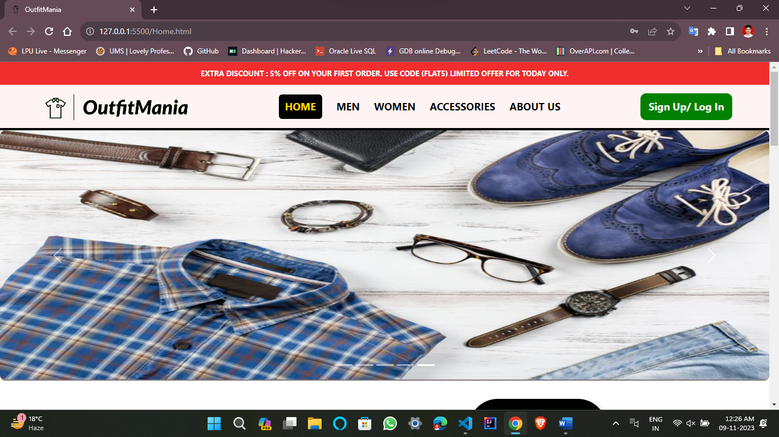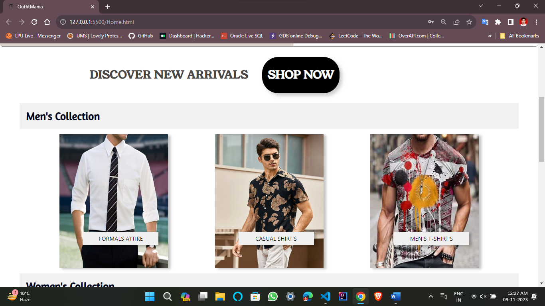

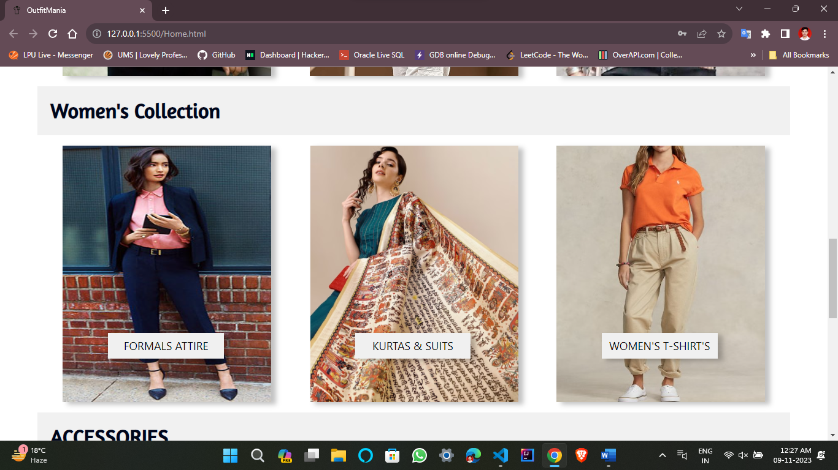

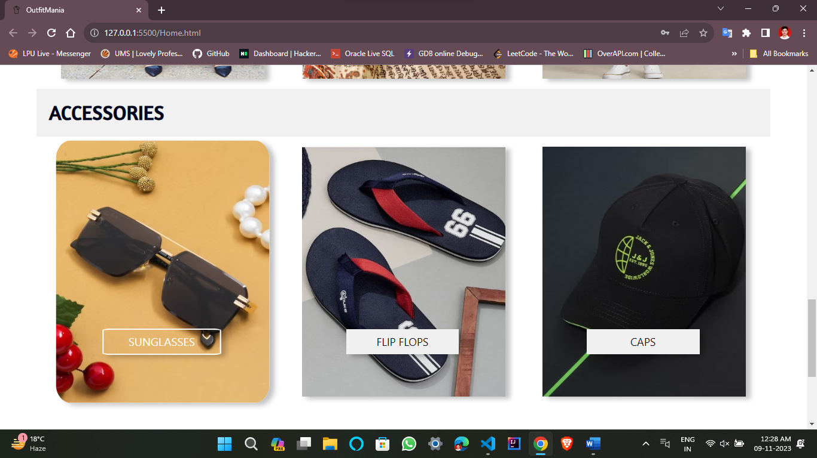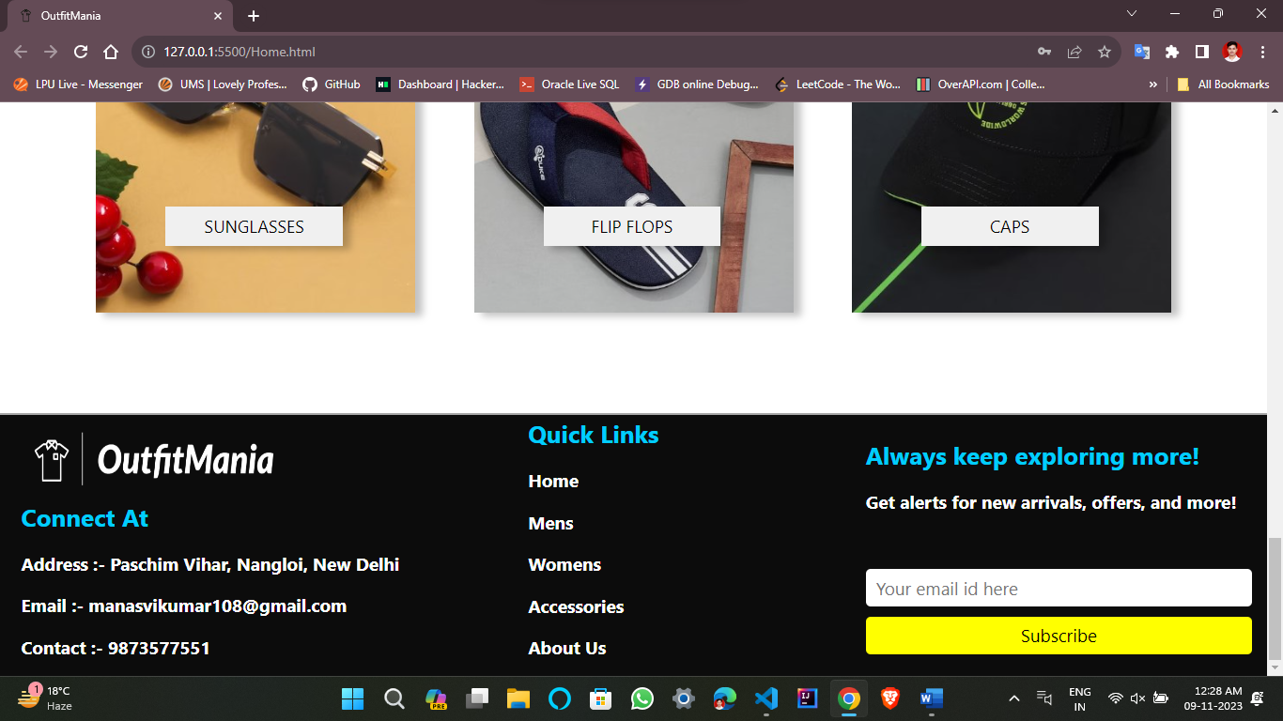

1. **Men**

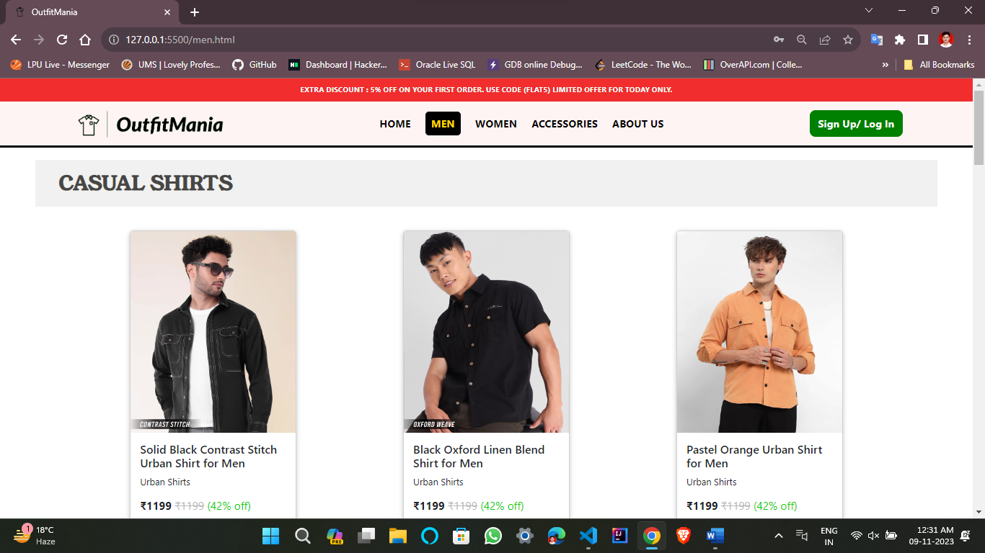

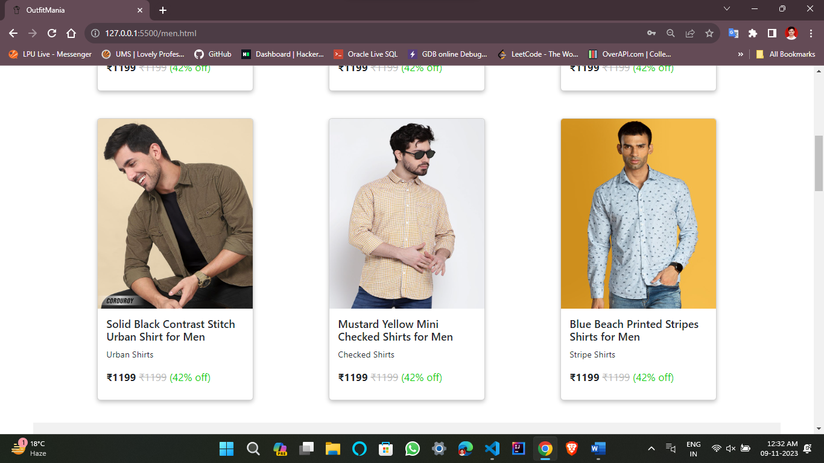 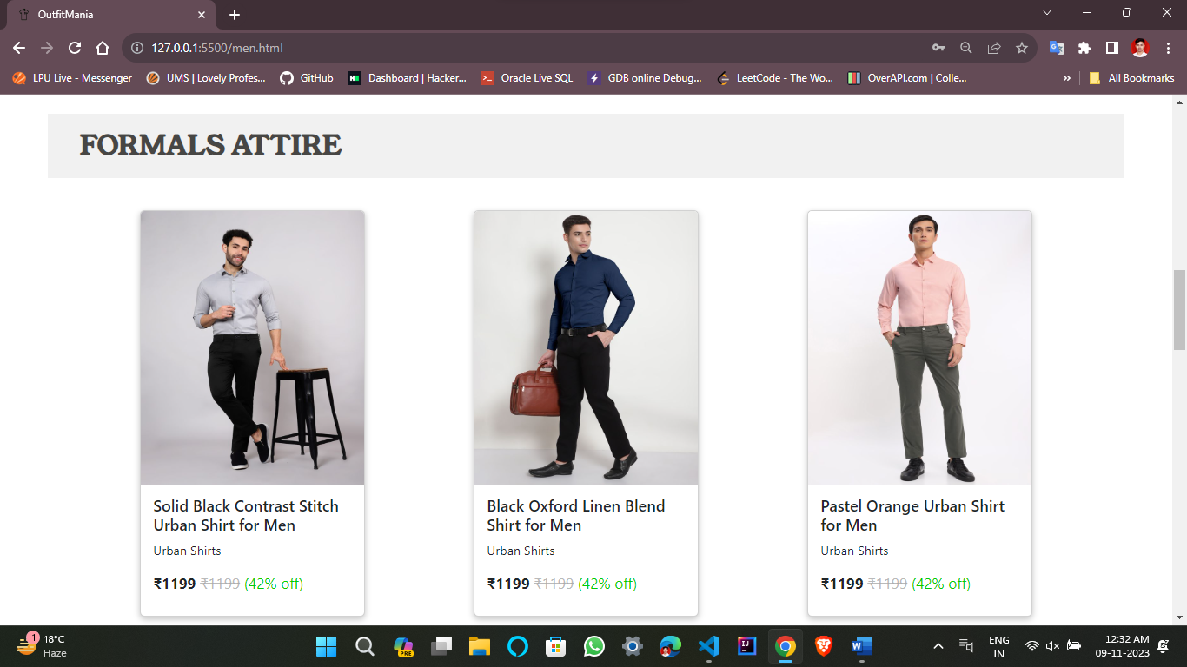 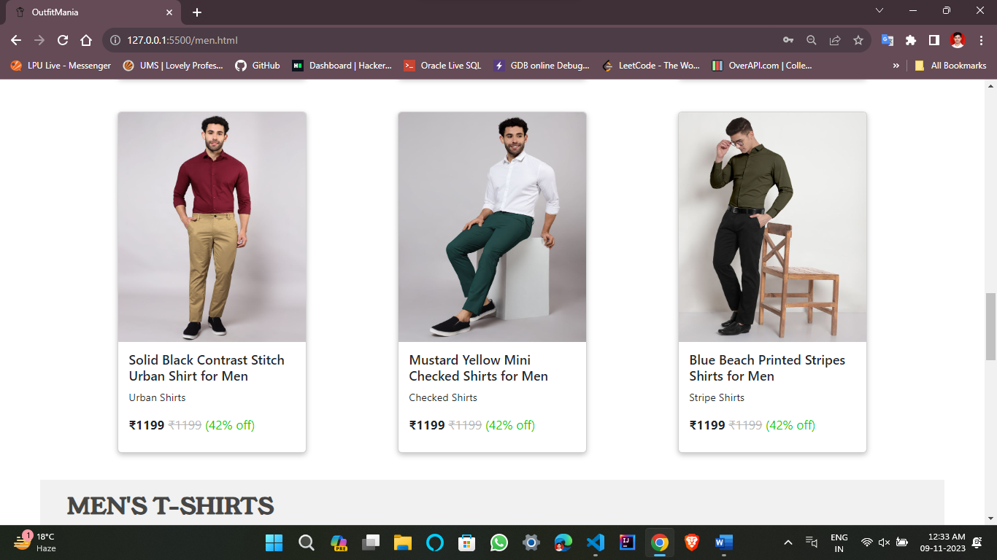 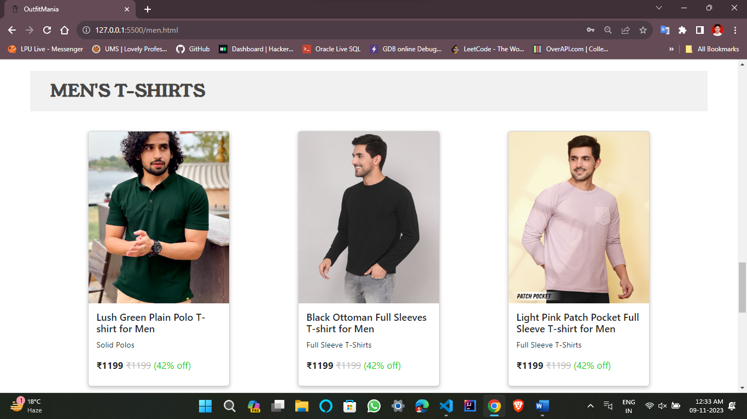 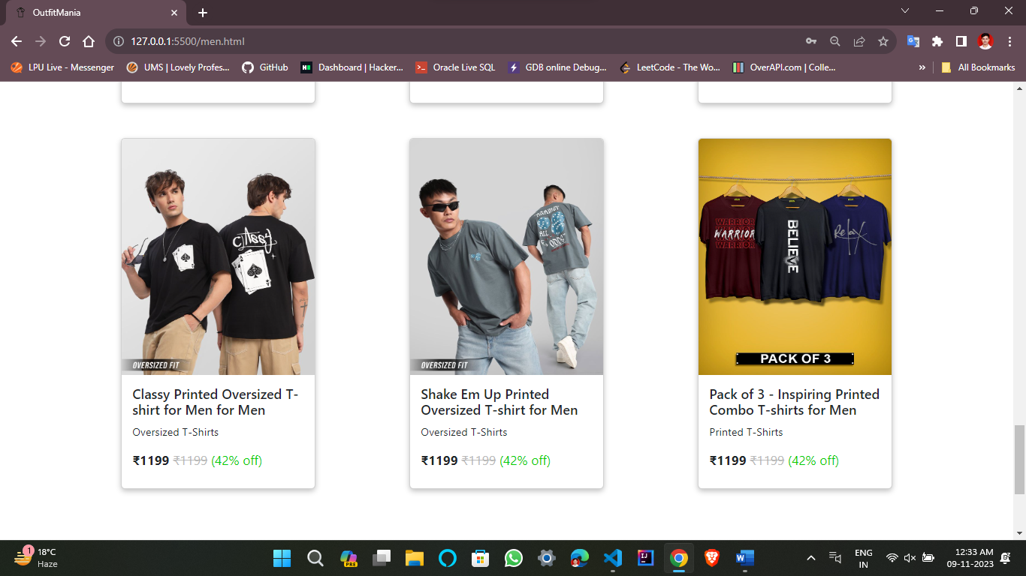 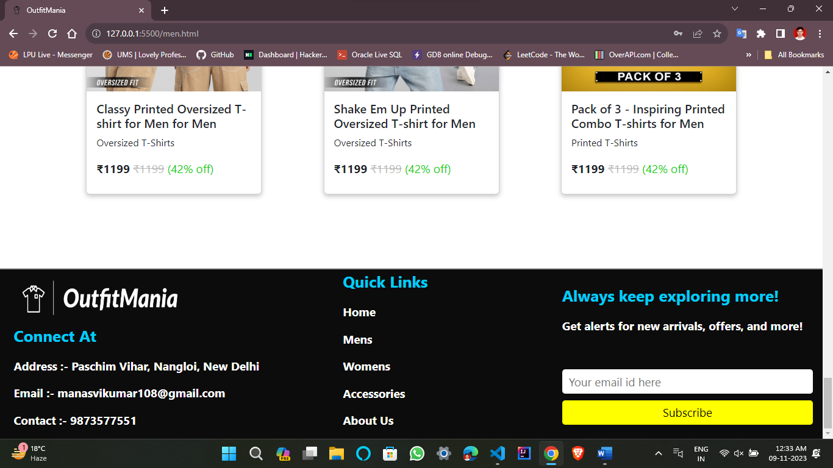

1. **Women**

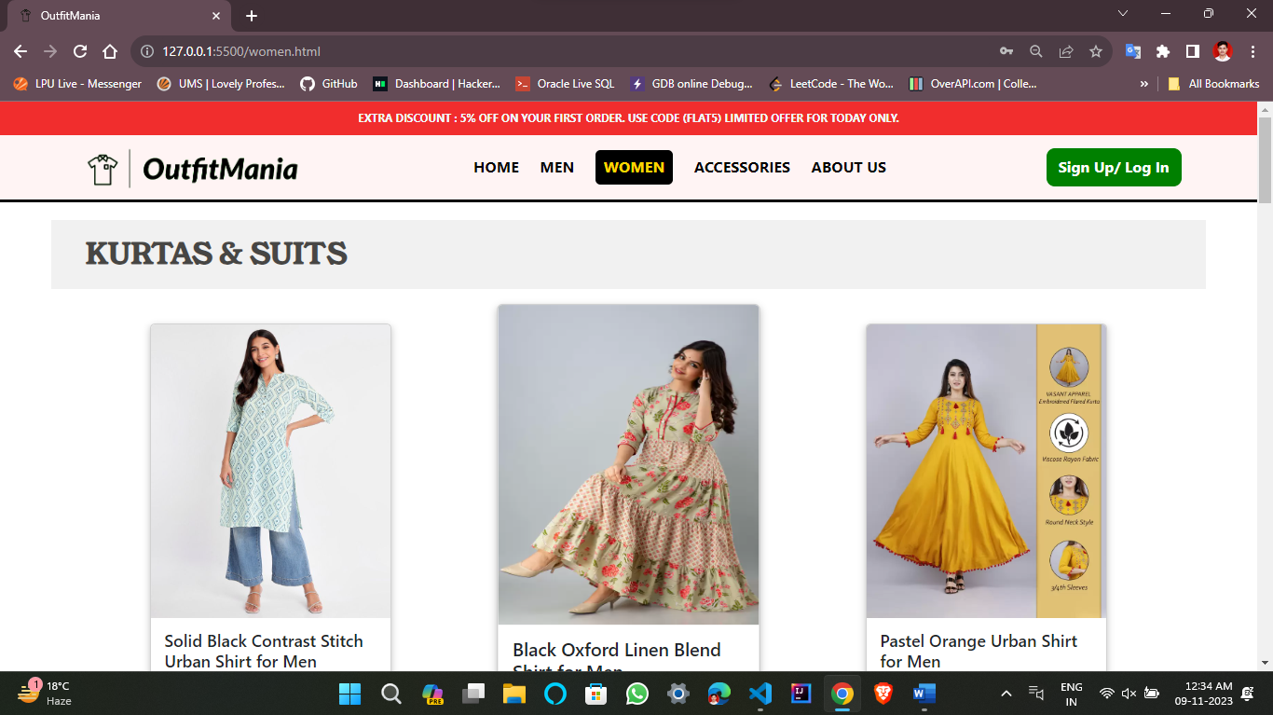 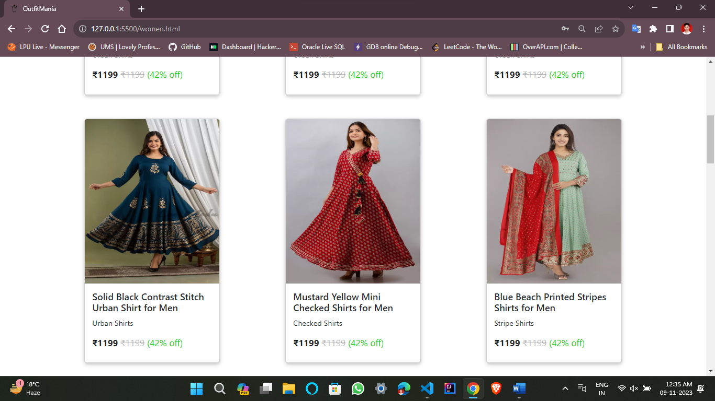 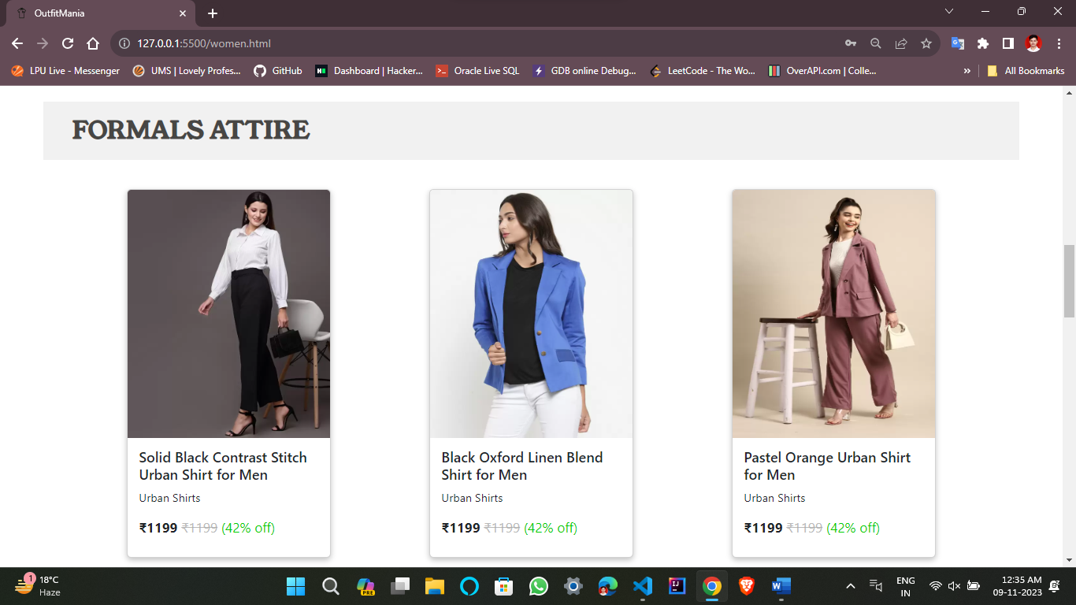 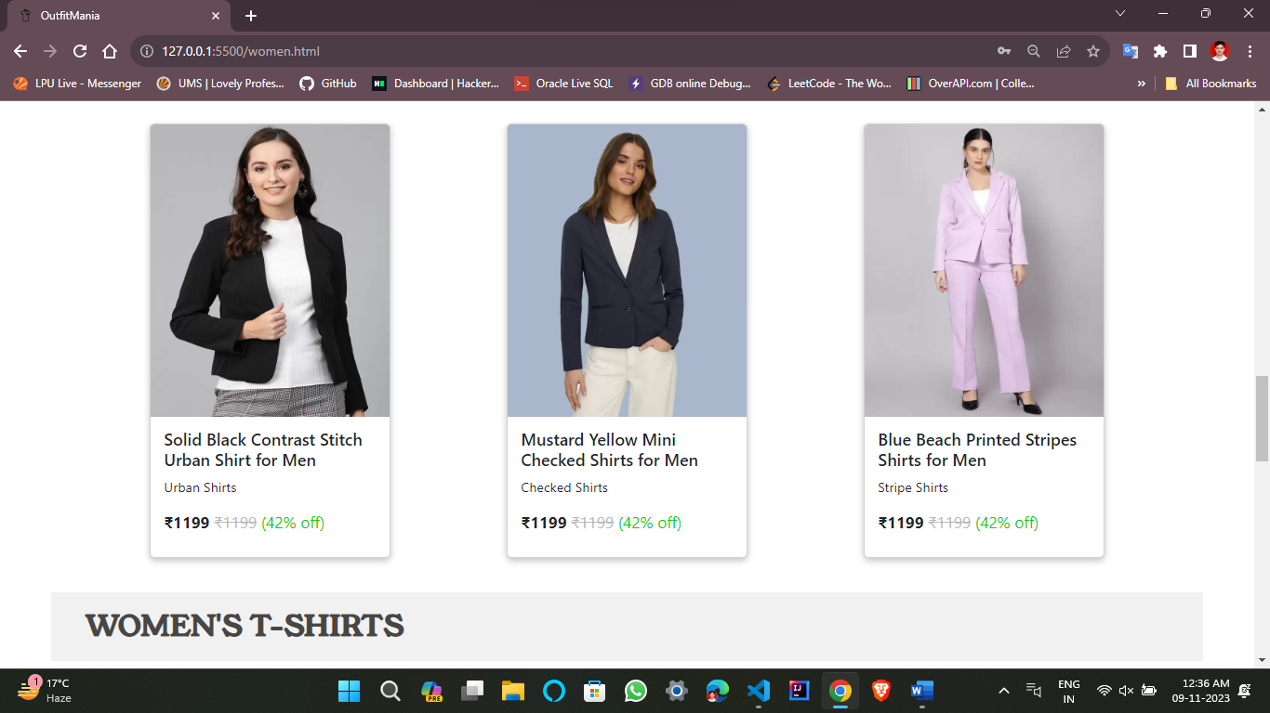 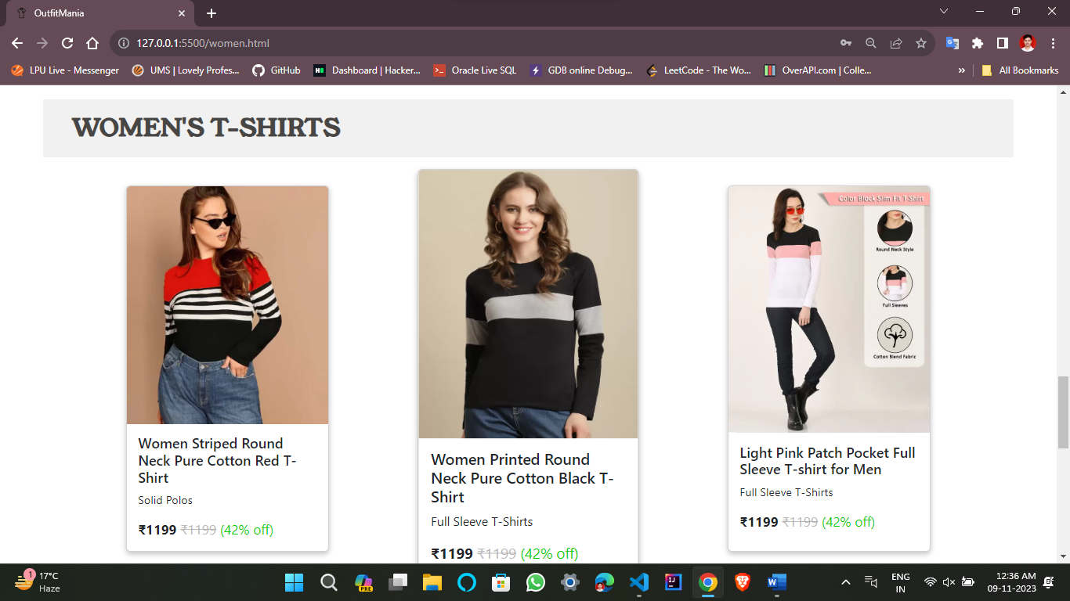

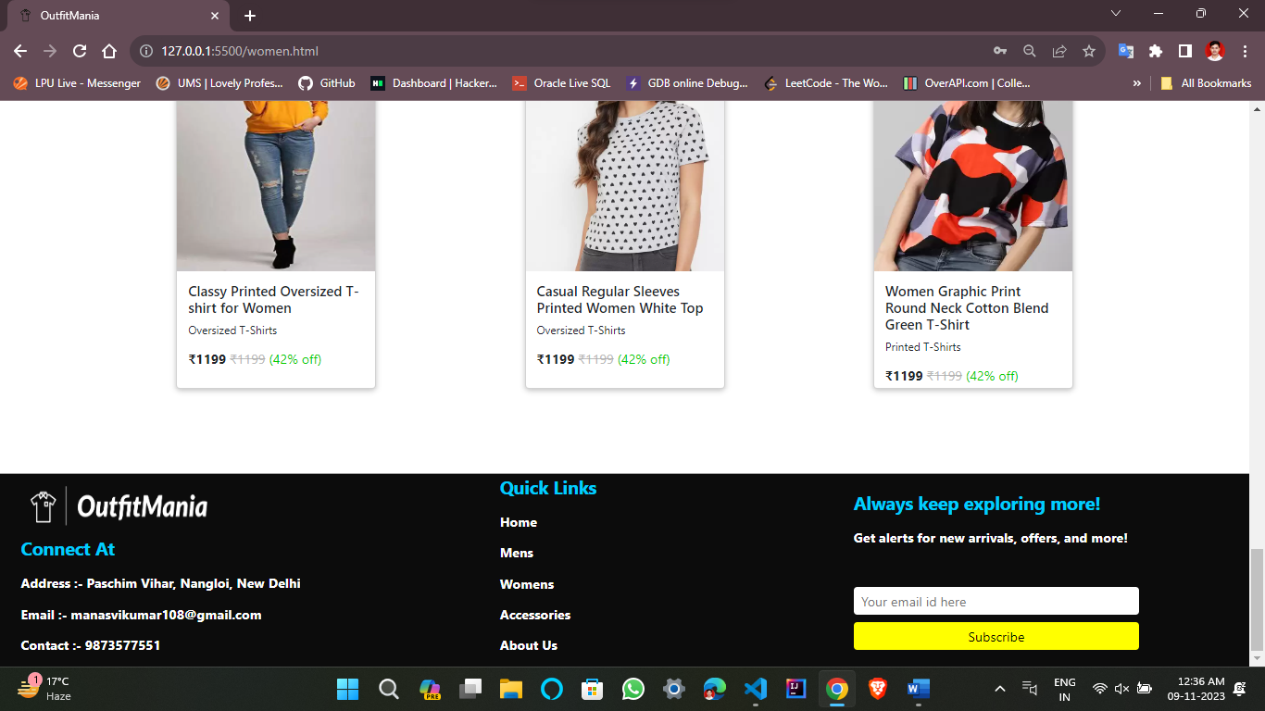

1. **Accessories**

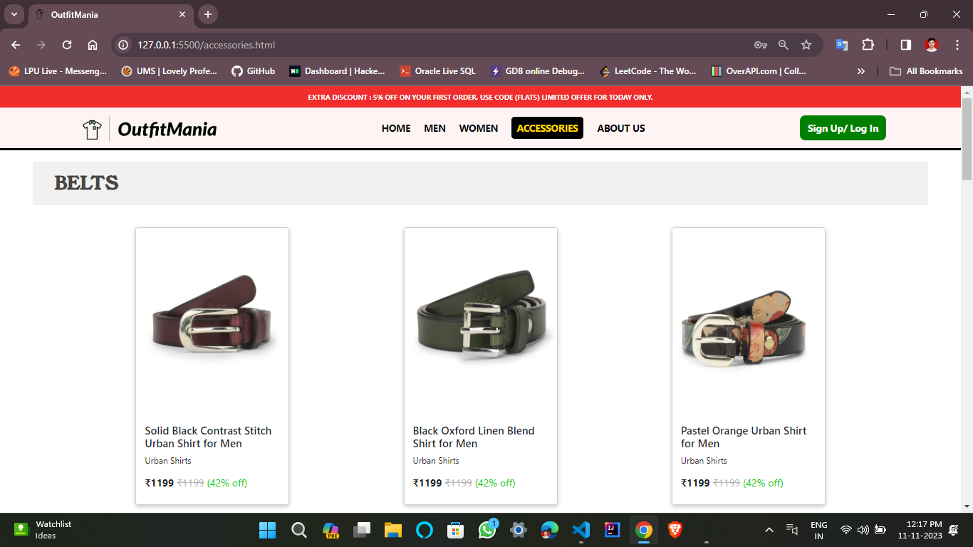 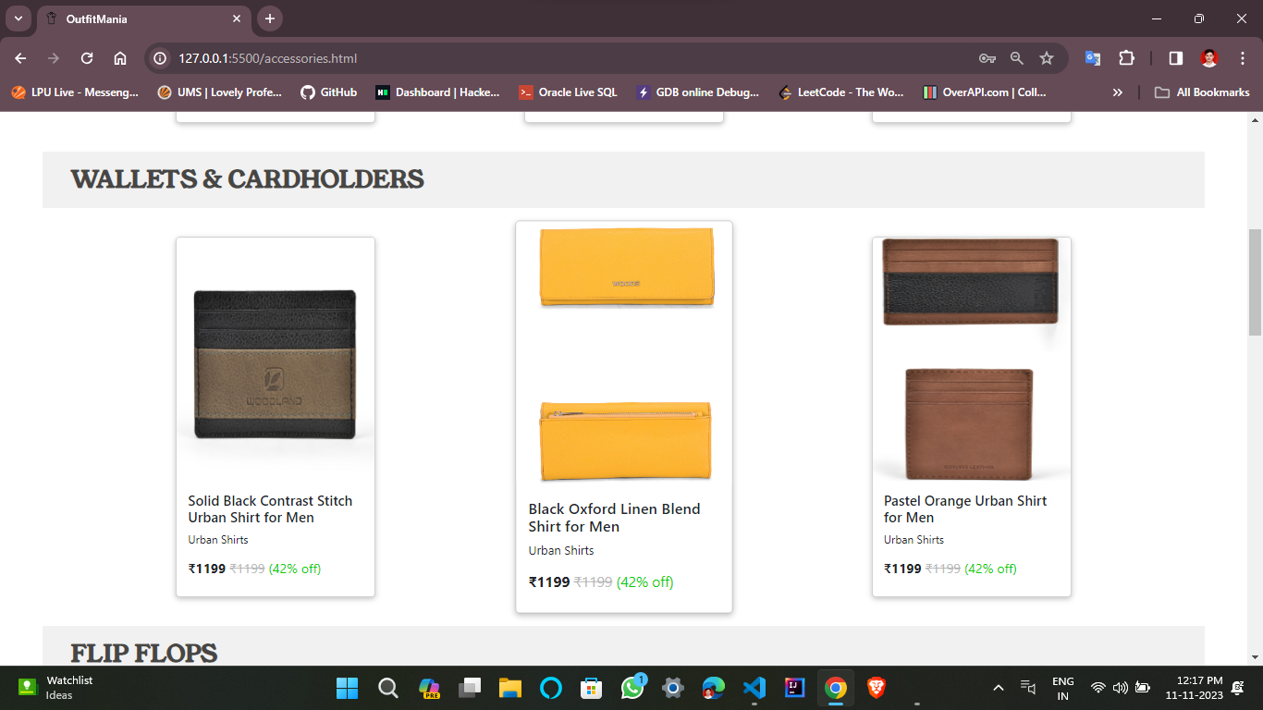 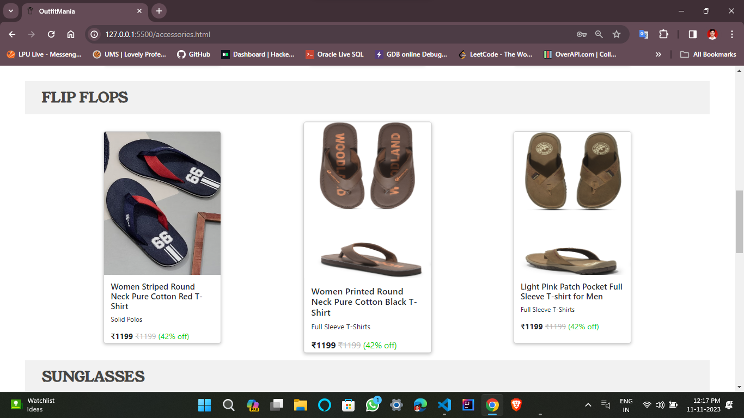 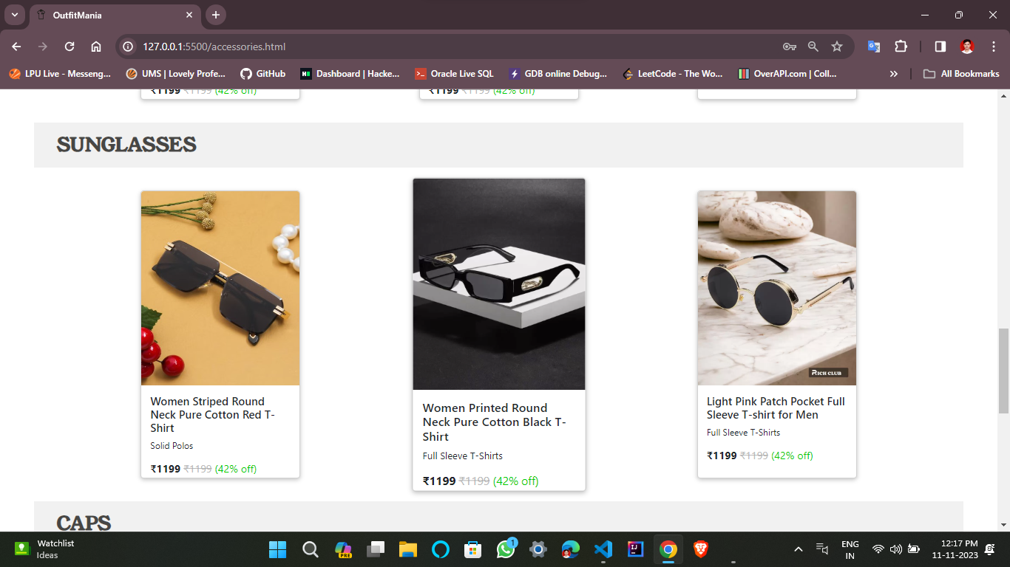 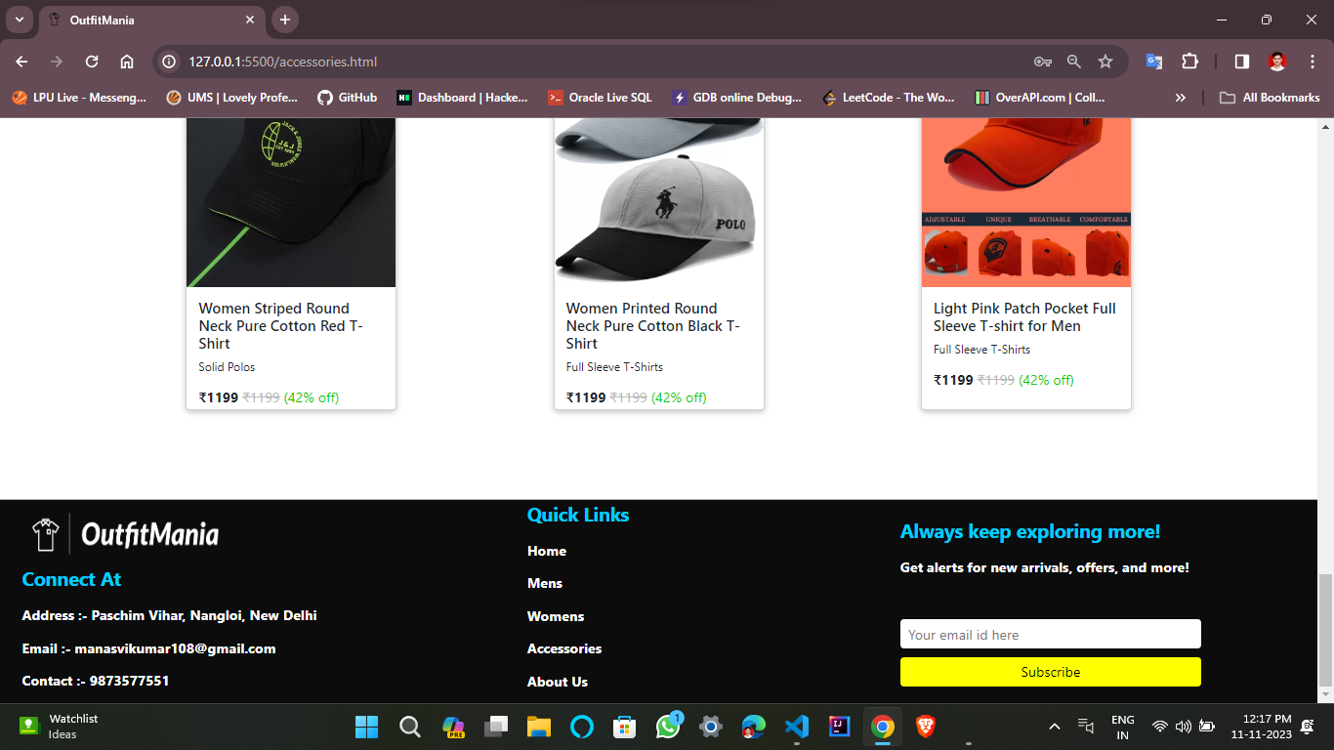

1. **About Us**

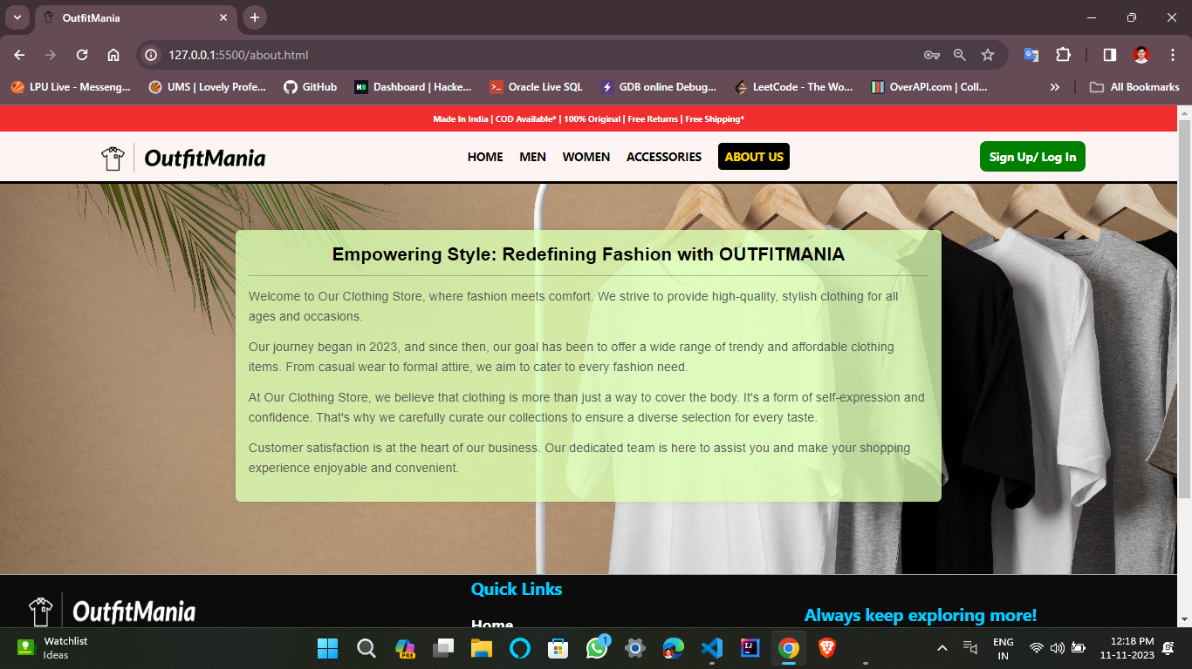

1. **Sign Up**

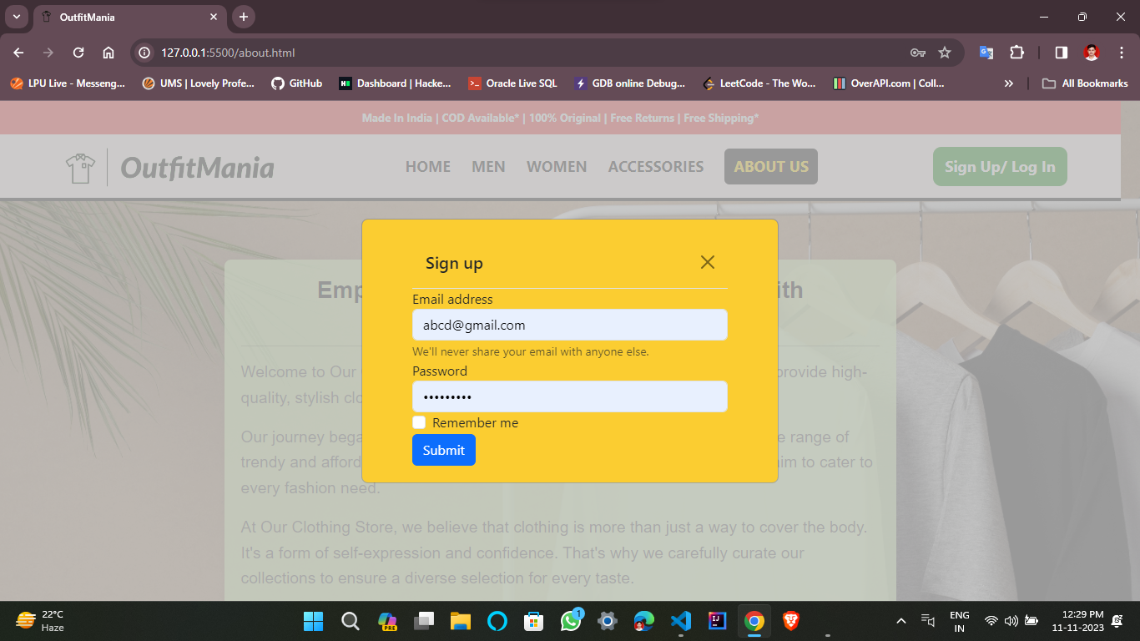

1. **Buy Now**

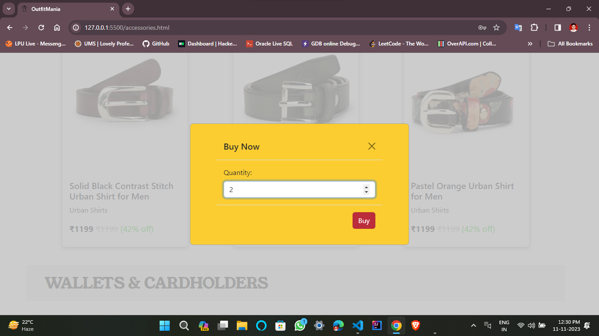

1. **Checkout Form**

